## Use Case Diagram

A Use Case Diagram visually shows how users (actors) interact with a system to achieve goals. It captures the system's main functions and illustrates what each user can do, helping to understand and communicate the system’s features.

**Key Components of a Use Case Diagram**

* **Actors**: Users or external systems that engage with the system are represented by actors. In this scenario, we have Cashier and Manager as the individuals involved.
* **Use Cases**: Represent the activities or capabilities that the system is able to carry out in reaction to user inputs. For example, "Login," "View Pet Supplies," "Add New Pet Supplies," and "Create New Cashier."
* **System Boundary**: It outlines the system's limits, encompassing all scenarios and separating internal processes from external entities.
* **Relationships**: Show the association between actors and use cases and include various types, such as:
* Include: Indicates mandatory functions that are always part of a use case (e.g. "Login" includes "Valid Username and Password").
* Extend: Represents optional or conditional functions that extend the base use case (e.g. "Search Pet Supplies" extends with "Sort Details").

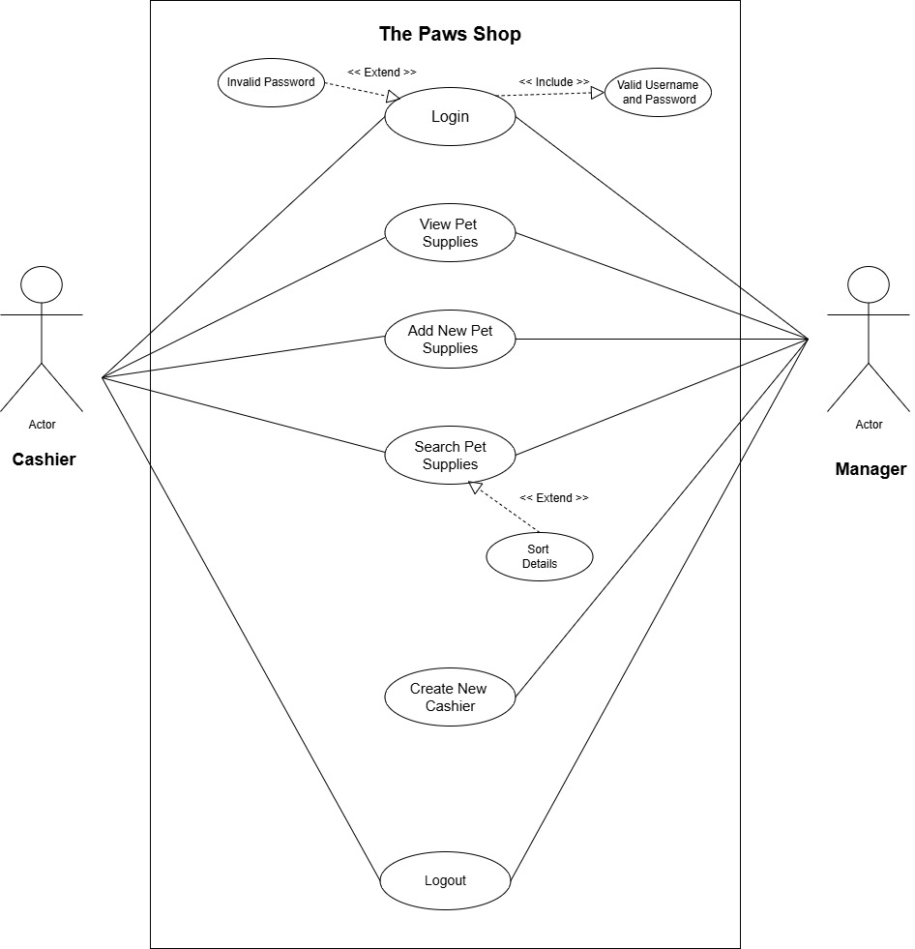

**Assumptions**

* **Actors:** Manager and Cashier
* **Use Cases:**
* Login Required - The system requires both Cashier and Manager to log in with a valid username and password.
* View Pet Supplies - Both Cashier and Manager can view details of all pet supplies.
* Add Pet Supplies - Both Cashier and Manager can add new pet supplies to the system.
* Search Pet Supplies - Both Cashier and Manager can search for pet supplies by category.
* Sort Search Results - Both Cashier and Manager can sort search.
* Create Cashier - Only the Manager can create new cashier accounts.
* Logout - Both Cashier and Manager can log out of the system when done.
* Role-Based Access - The Manager has more permissions (like creating cashier accounts) than the Cashier.

## Class Diagram

A class diagram is a visual representation of a system's structure, showing its classes, attributes, methods, and relationships. Each class is depicted with its name, properties, and behaviors, while lines between classes illustrate how they interact, helping developers understand the overall design of the system.

**Assumptions**

* **Inheritance**
* Manager and Cashier inherit from User.
* **Associations**
* Manager to PetSupply: Manager can view, add and search pet supplies.
* Cashier to PetSupply: Cashier also has permissions to view, add and search pet supplies, but likely with less authority than the manager.
* PetSupply to Category: Each pet supply is linked to a category, allowing classification of supplies.
* File Handling: Manages data saving and loading for User, PetSupply, and Category classes.

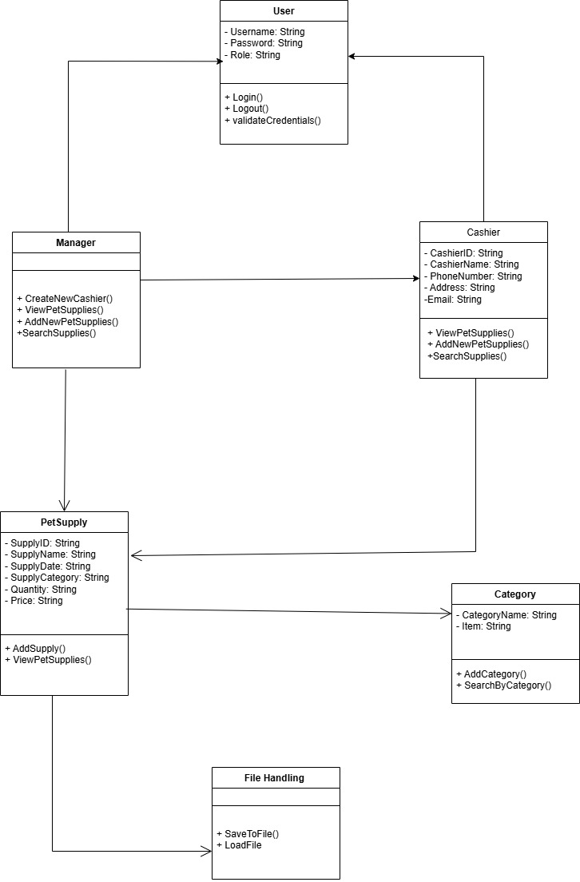

## Sequence Diagram

A sequence diagram illustrates the step-by-step interaction of components within a system. It demonstrates the process of objects communicating to accomplish a goal. Every item contains a vertical line, with arrows indicating the sequence of messages. This facilitates understanding the system's functioning and the interaction of its components.

* Login

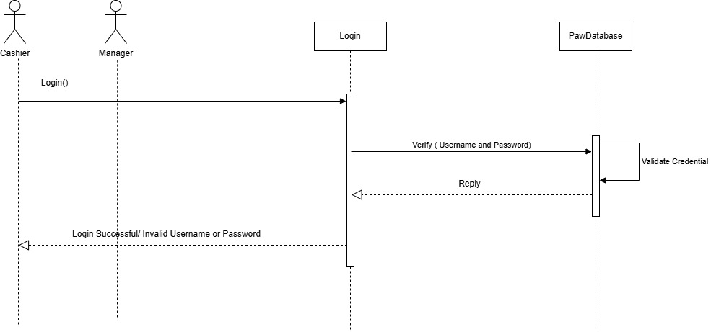

* 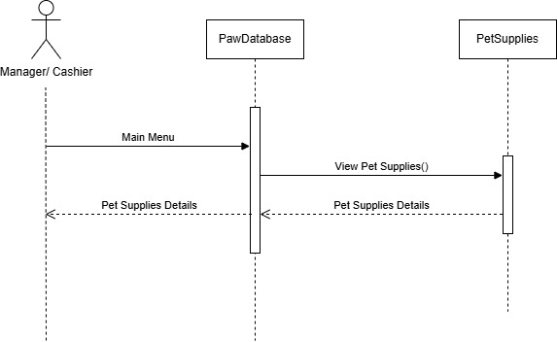View Pet Supplies
* Add New Supplies

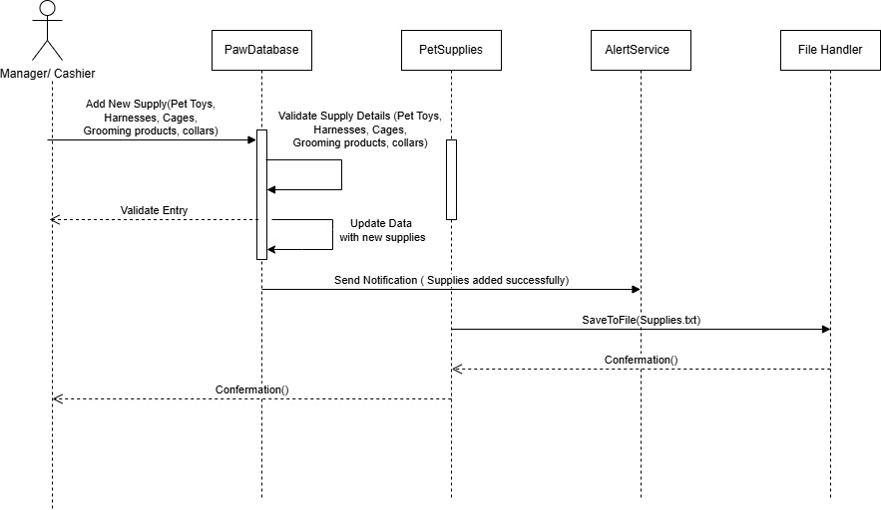

* Add Category

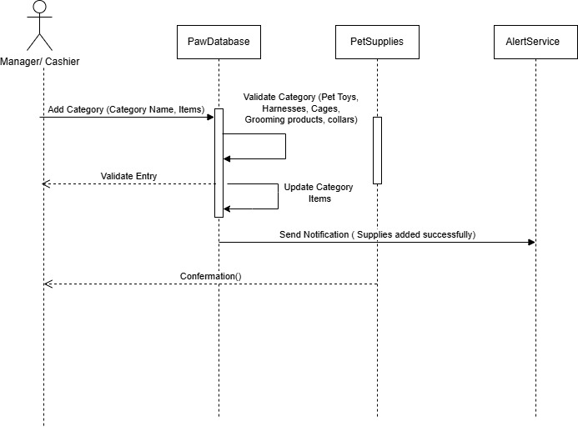

* 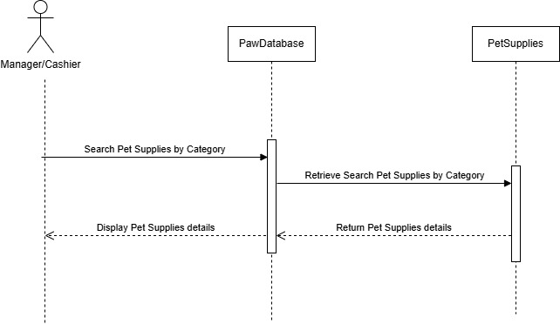Search Pet Supplies
* Create New Cashier

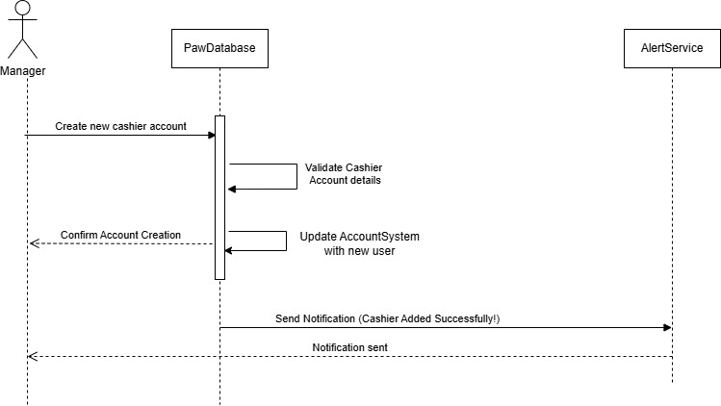**Login Interface**

This Java Swing application provides a simple login interface with fields for a username and password. Upon clicking the "LOGIN" button, it verifies the entered credentials against predefined values. If the username and password are correct, it opens the respective `Admin` or `Cashier` interface. If the credentials are incorrect, it displays an error message.

* 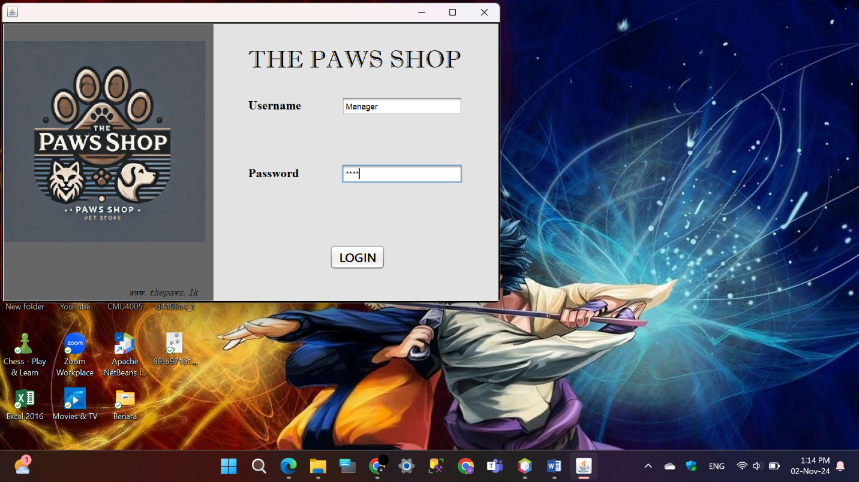**Manager**
* **Cashier** 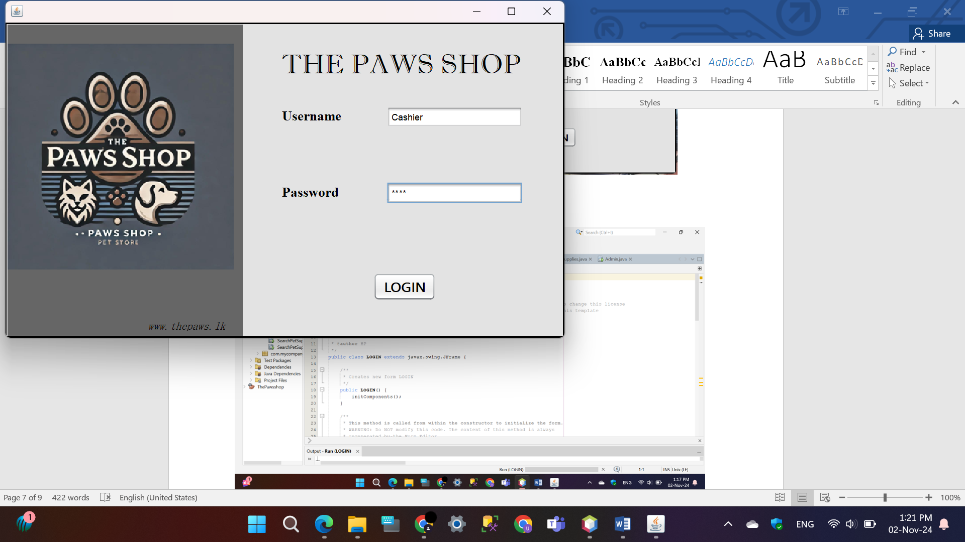

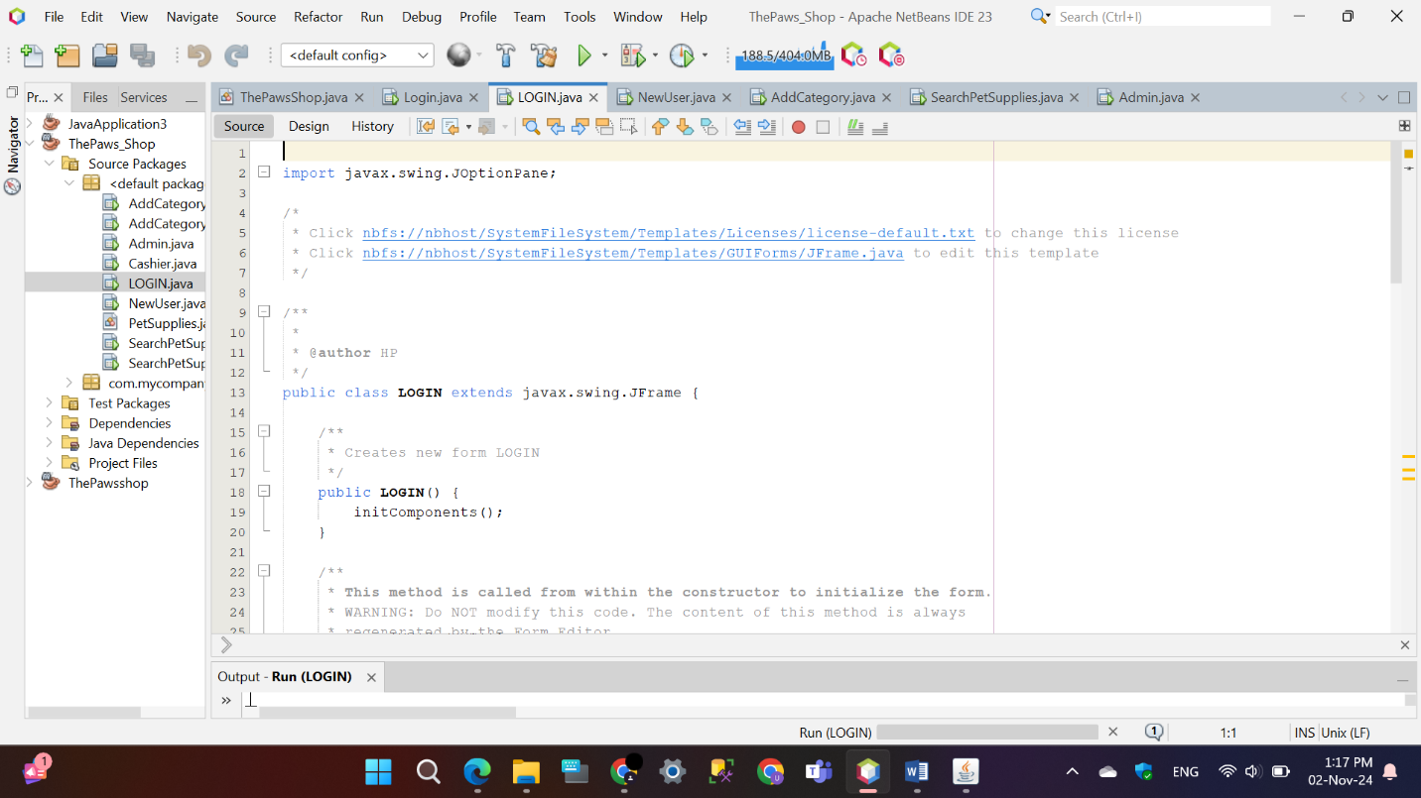

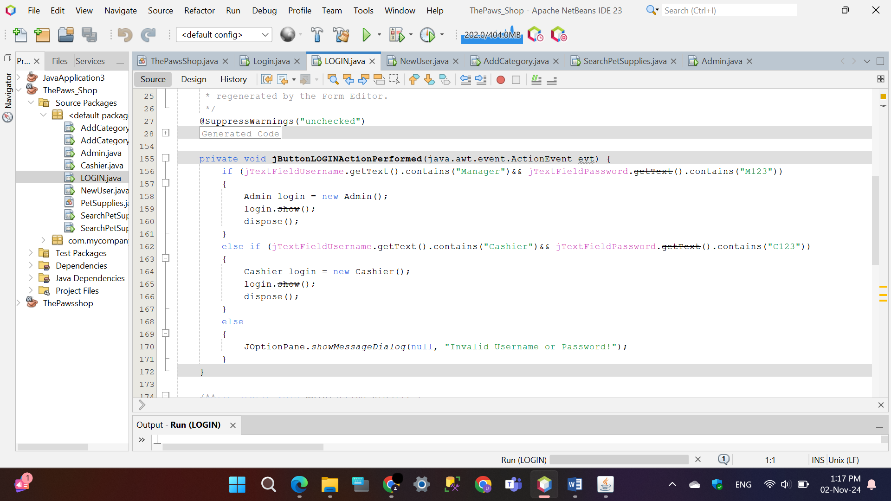

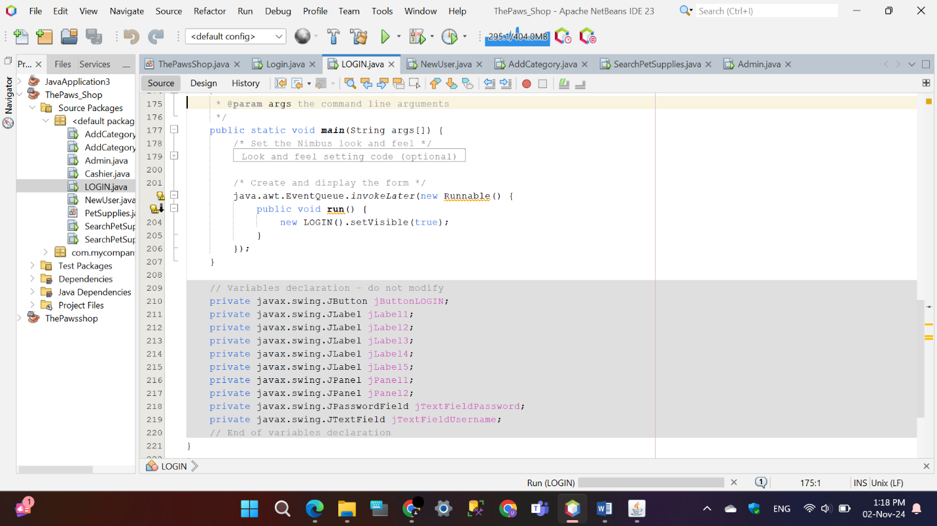

## Main Menu

The `Admin` and `Cashier` classes provide the main menu interfaces for an administrative and cashier role in a pet supplies management system. Both GUIs feature clearly labeled buttons that allow users to view and manage pet supplies, add new items and categories, and search for specific products. The `Admin` menu includes options for creating cashier accounts, while both interfaces ensure a seamless user experience with a "Logout" button for signing out. The design prioritizes usability and efficient navigation for effective inventory management.

* 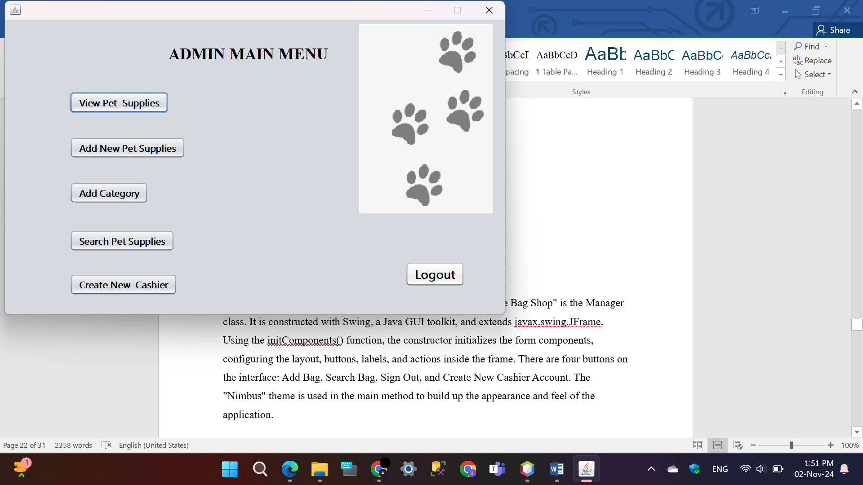**Manager**

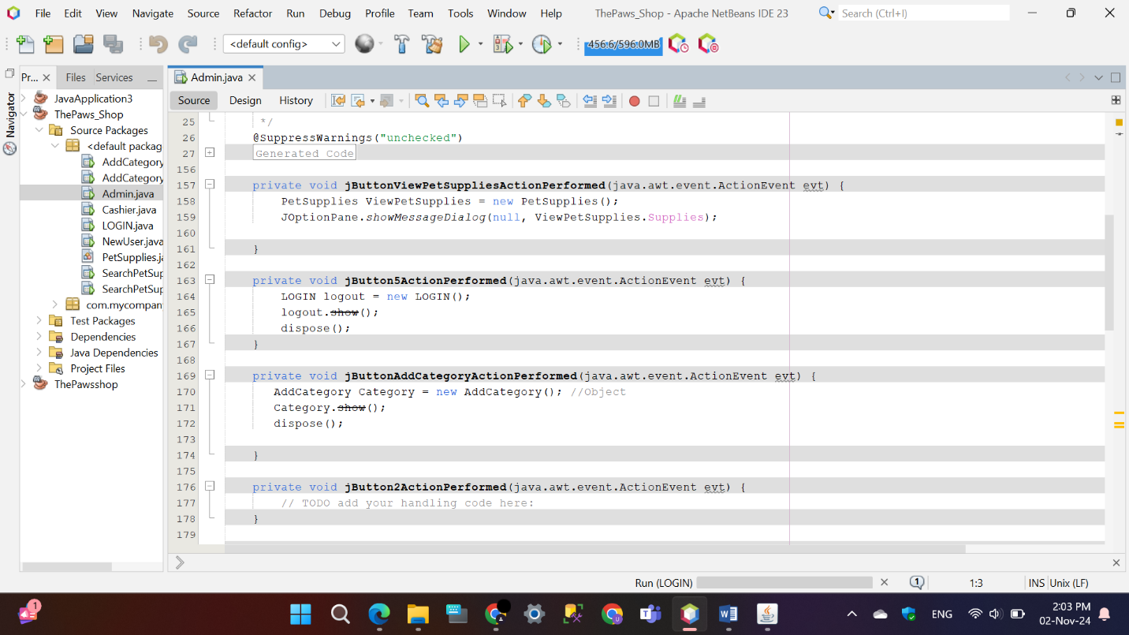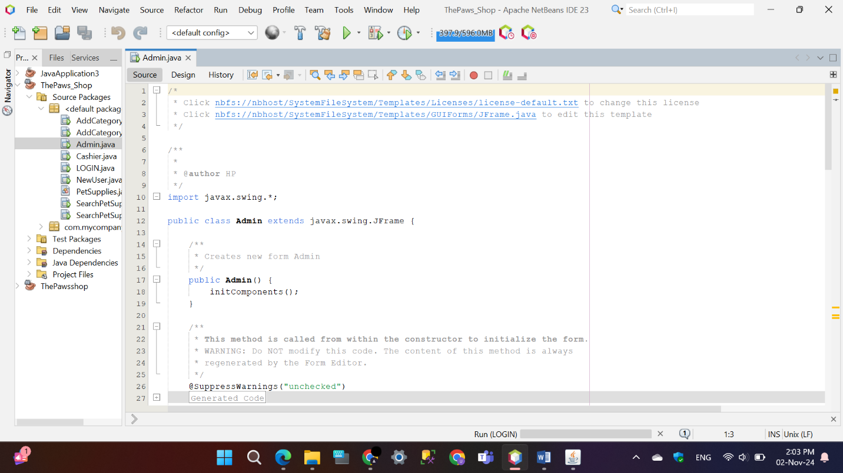

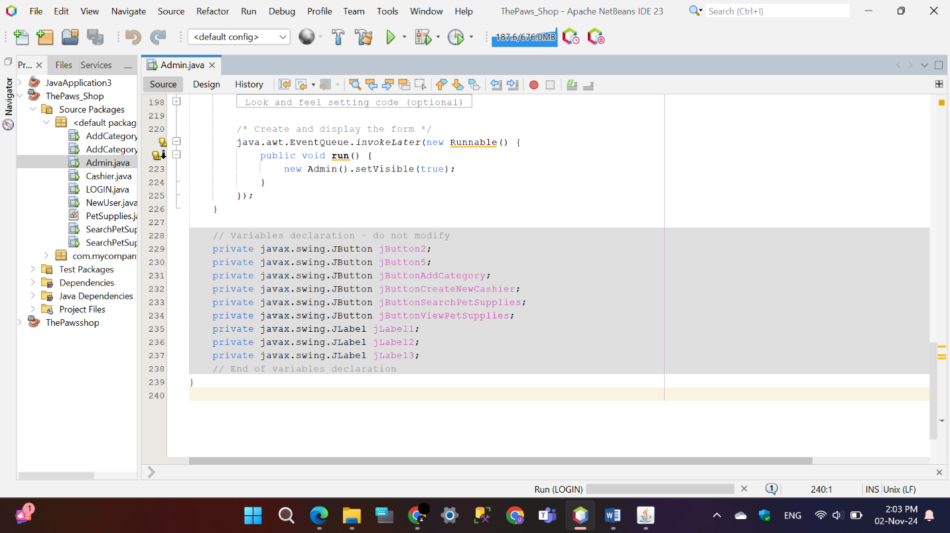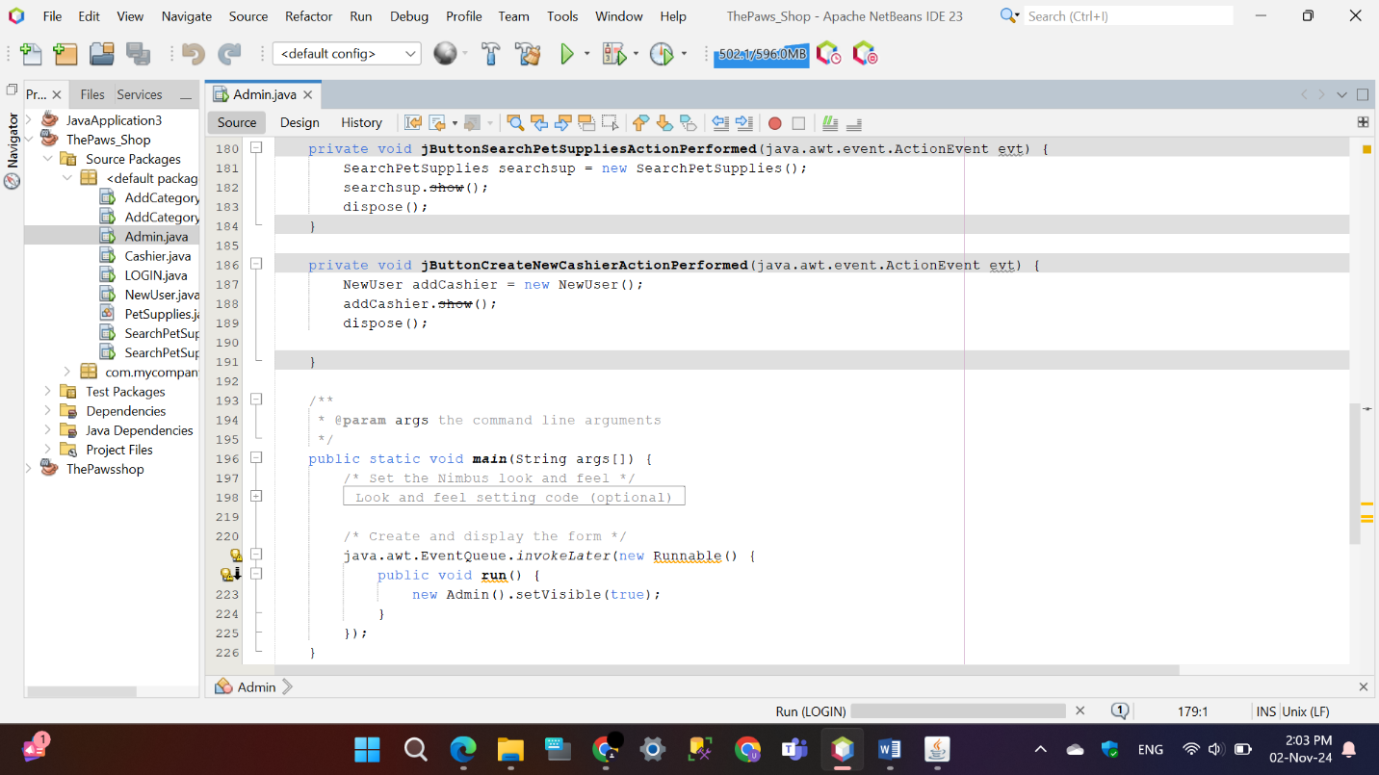

* 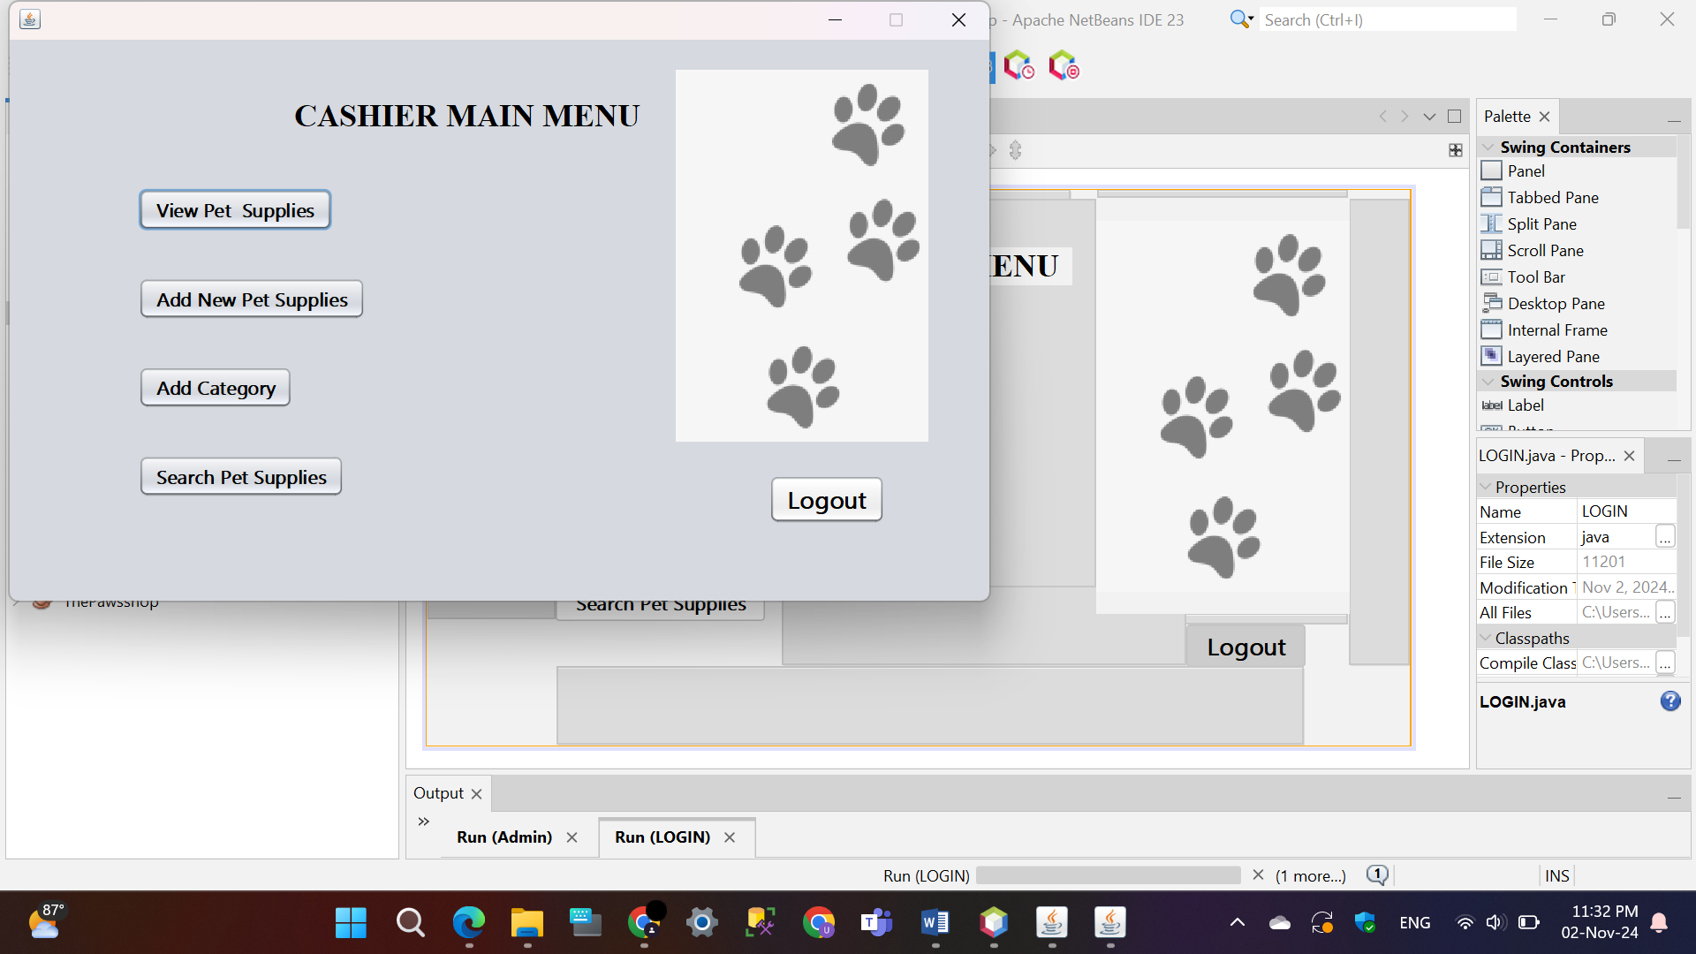**Cashier**

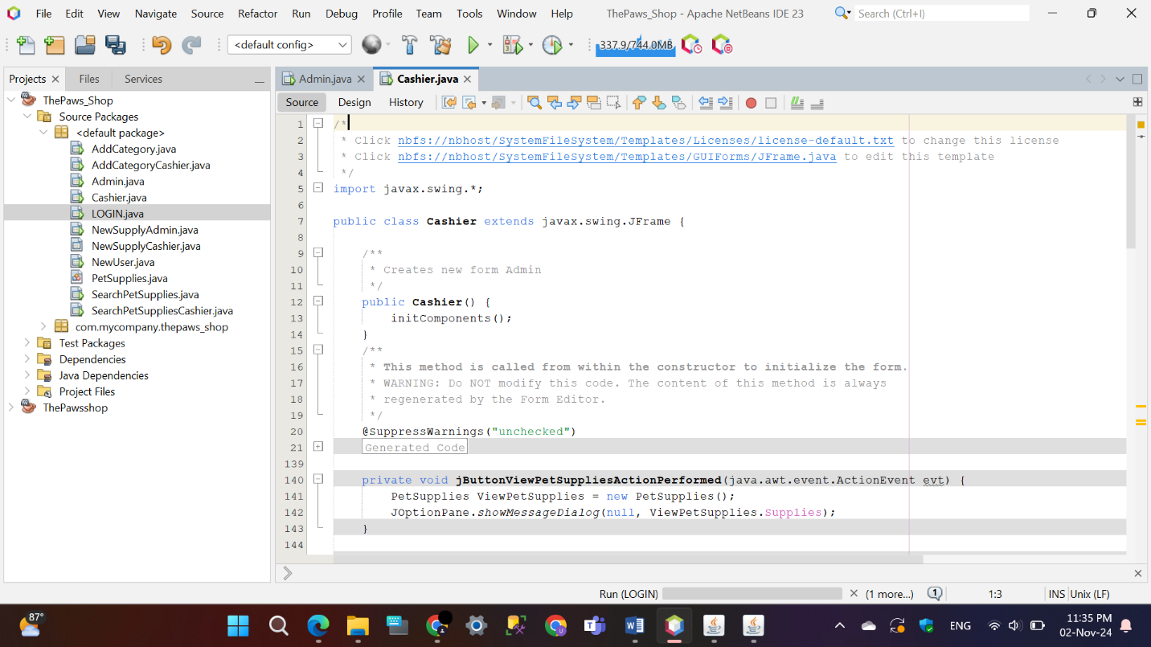

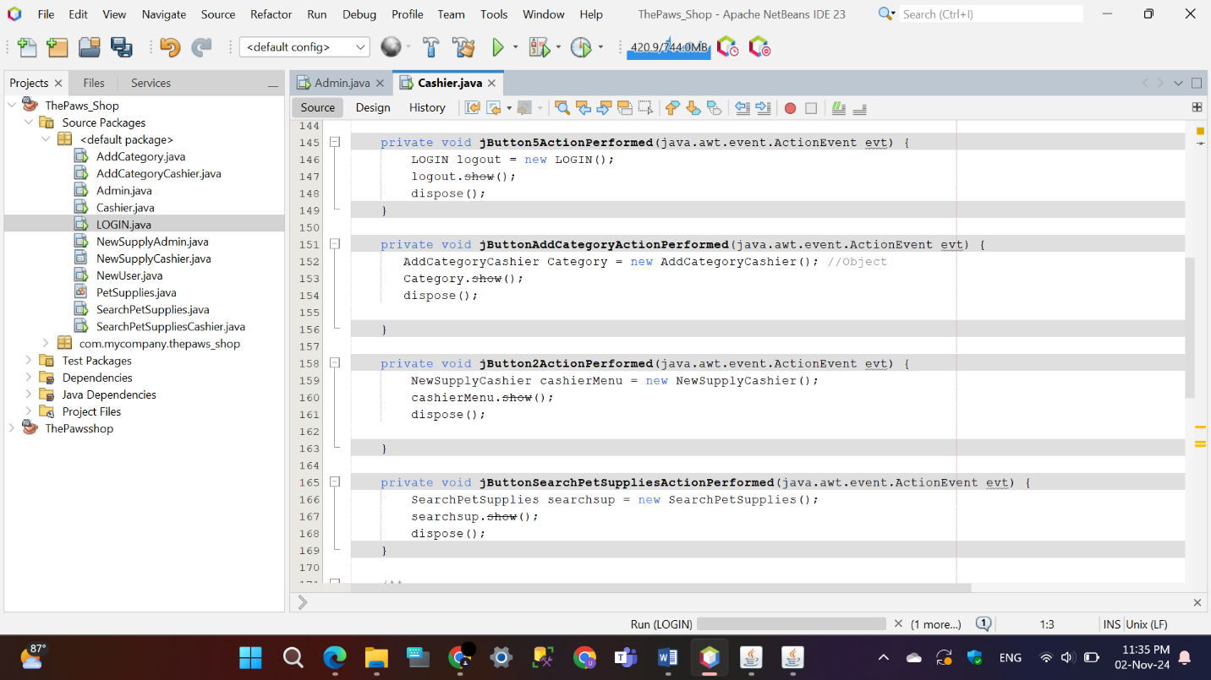

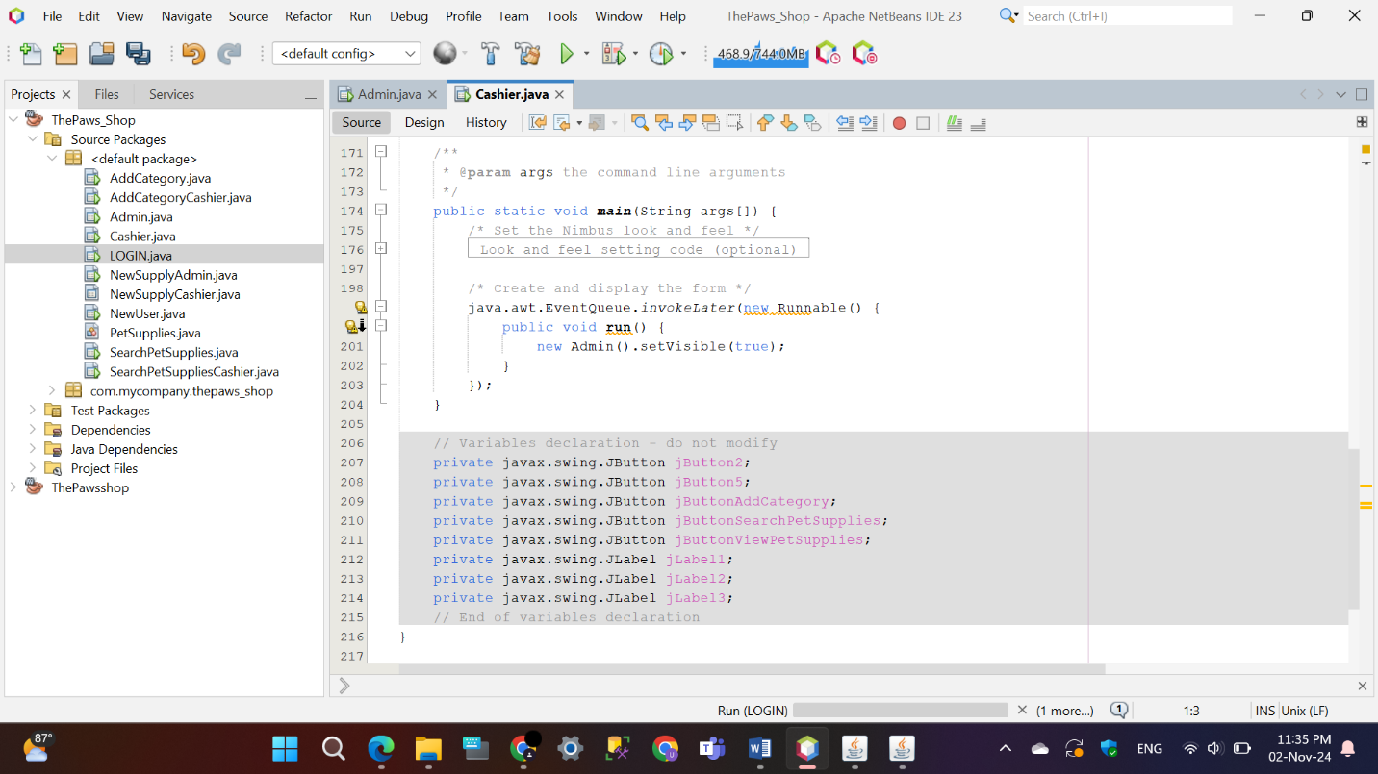

## View Pet Supplies

The ‘jButtonViewPetSuppliesActionPerformed’ method is an event handler that activates when a button labeled “View Pet Supplies” is clicked in a Java Swing application. t instantiates the ‘PetSupplies’ class, which has a collection of pet items such as “Pet Toys”, “Harnesses”, “Cages”, “Grooming Products”, “Collars”, and “Food”. Using ‘JOptionPane.showMessageDialog’, the method displays a dialog box to the user that presents this list of supplies, allowing for easy viewing of the available items. In order to improve user-friendliness, the list could be converted into a more legible format before being displayed in the dialog.

* **Manager**

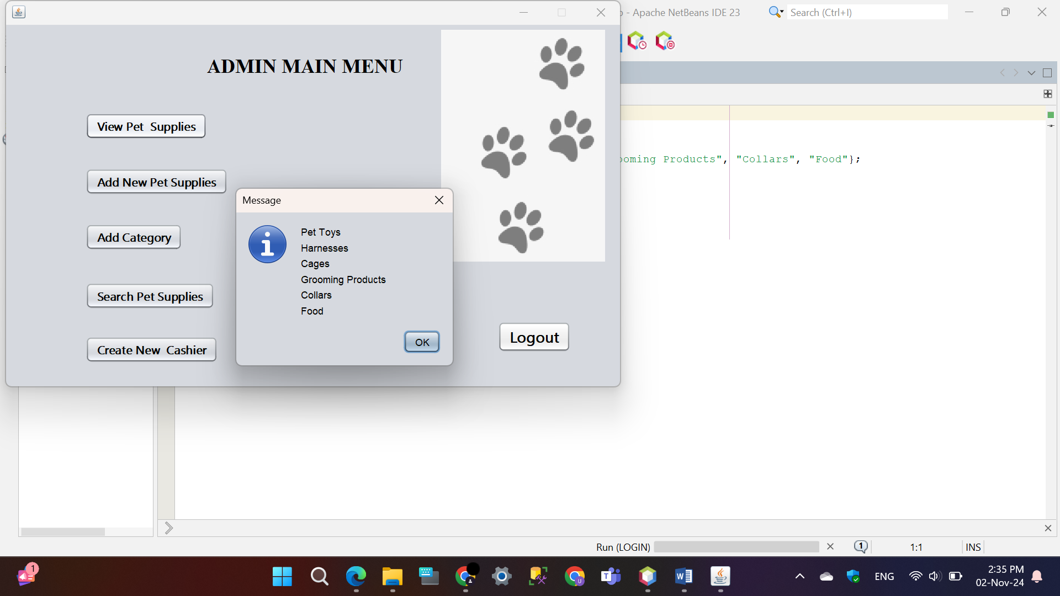

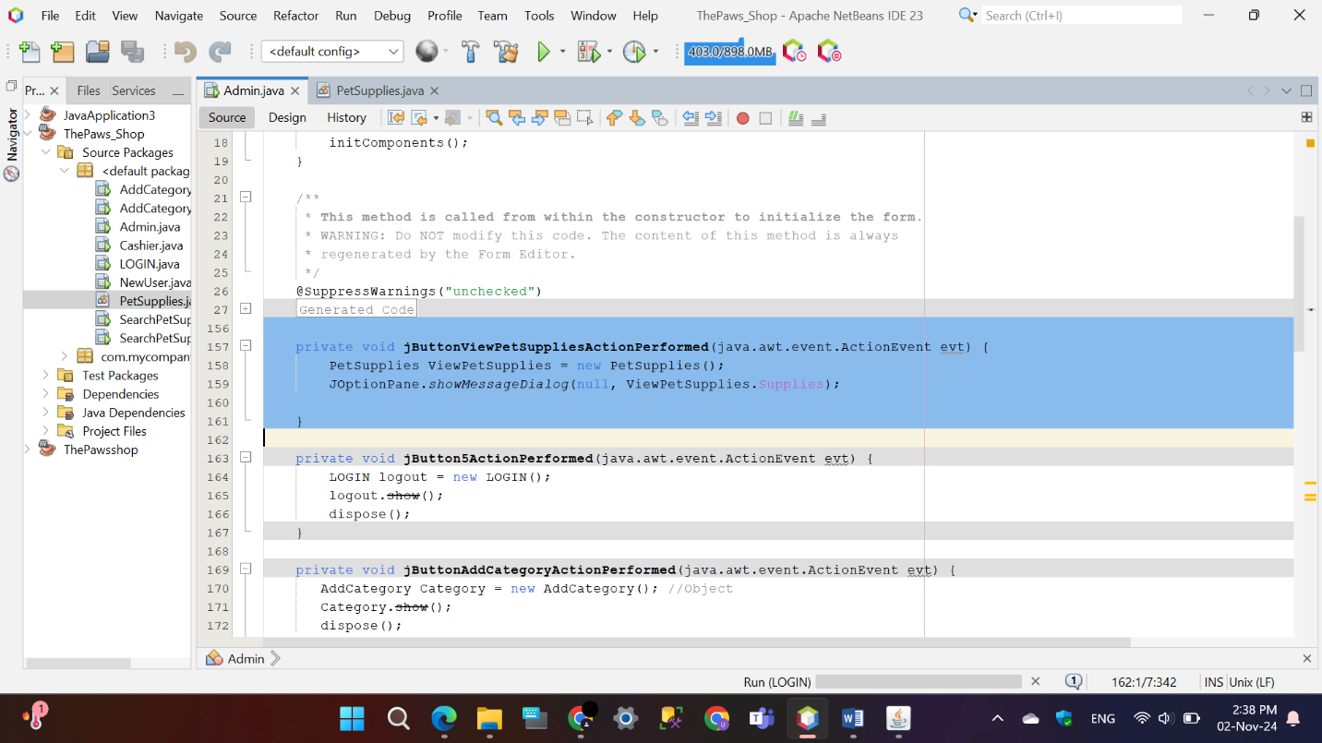

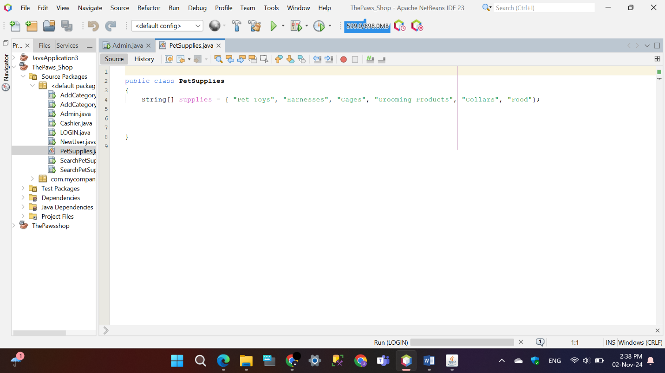

* 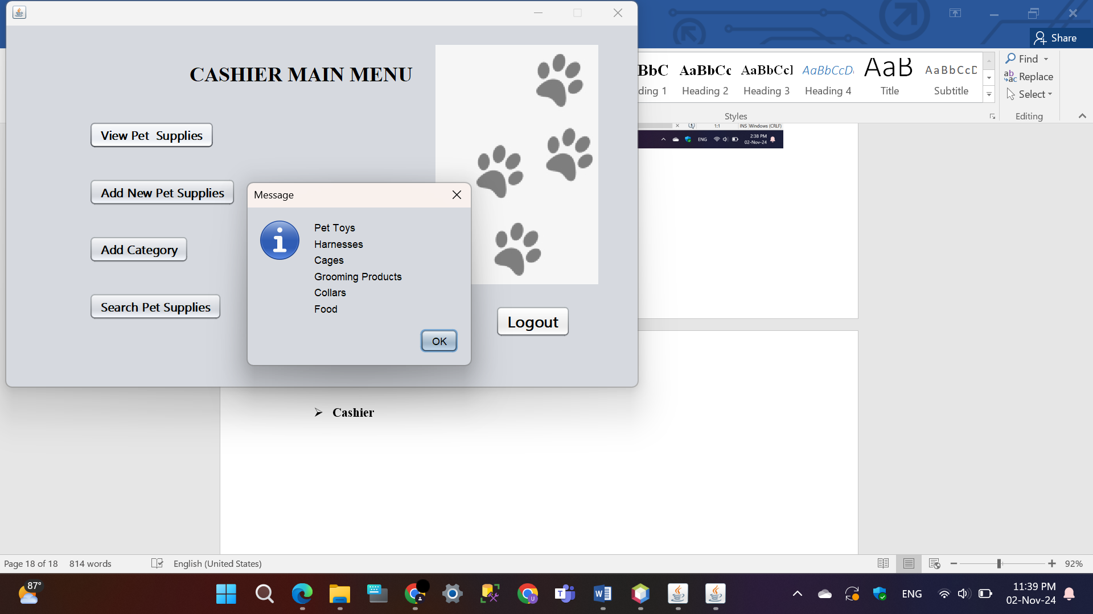**Cashier**

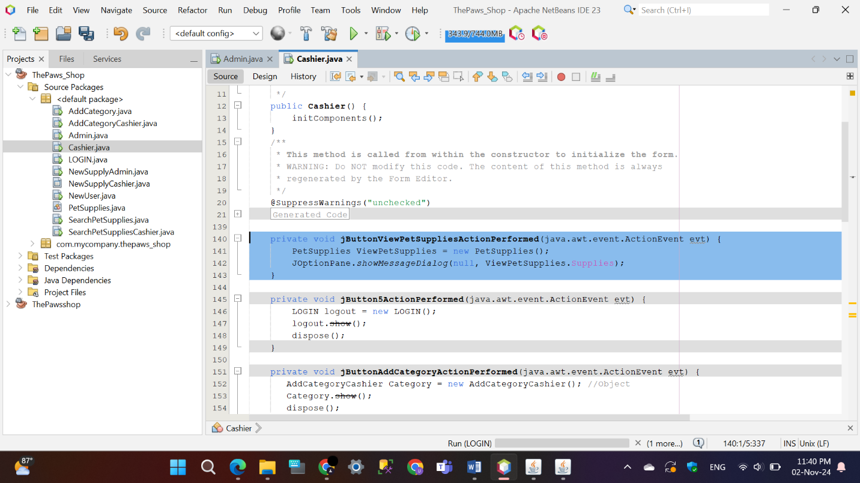



## Add New Pet Supplies

The ‘NewSupplyCashier’ and ‘NewSupplyAdmin’ Java Swing application offers a user-friendly interface for cashiers to manage supply entries. It includes fields for supply ID, name, date, quantity, and price, along with buttons to add entries, view existing supplies, and navigate back. When the “ADD” button is clicked, the details are saved to a file (‘Supplies.txt’), and a confirmation dialog is shown. The “View Added Supplies” button displays entries from the file, and basic exception handling is implemented for error logging. This application effectively handles file operations, making it a practical tool for supply management.

* 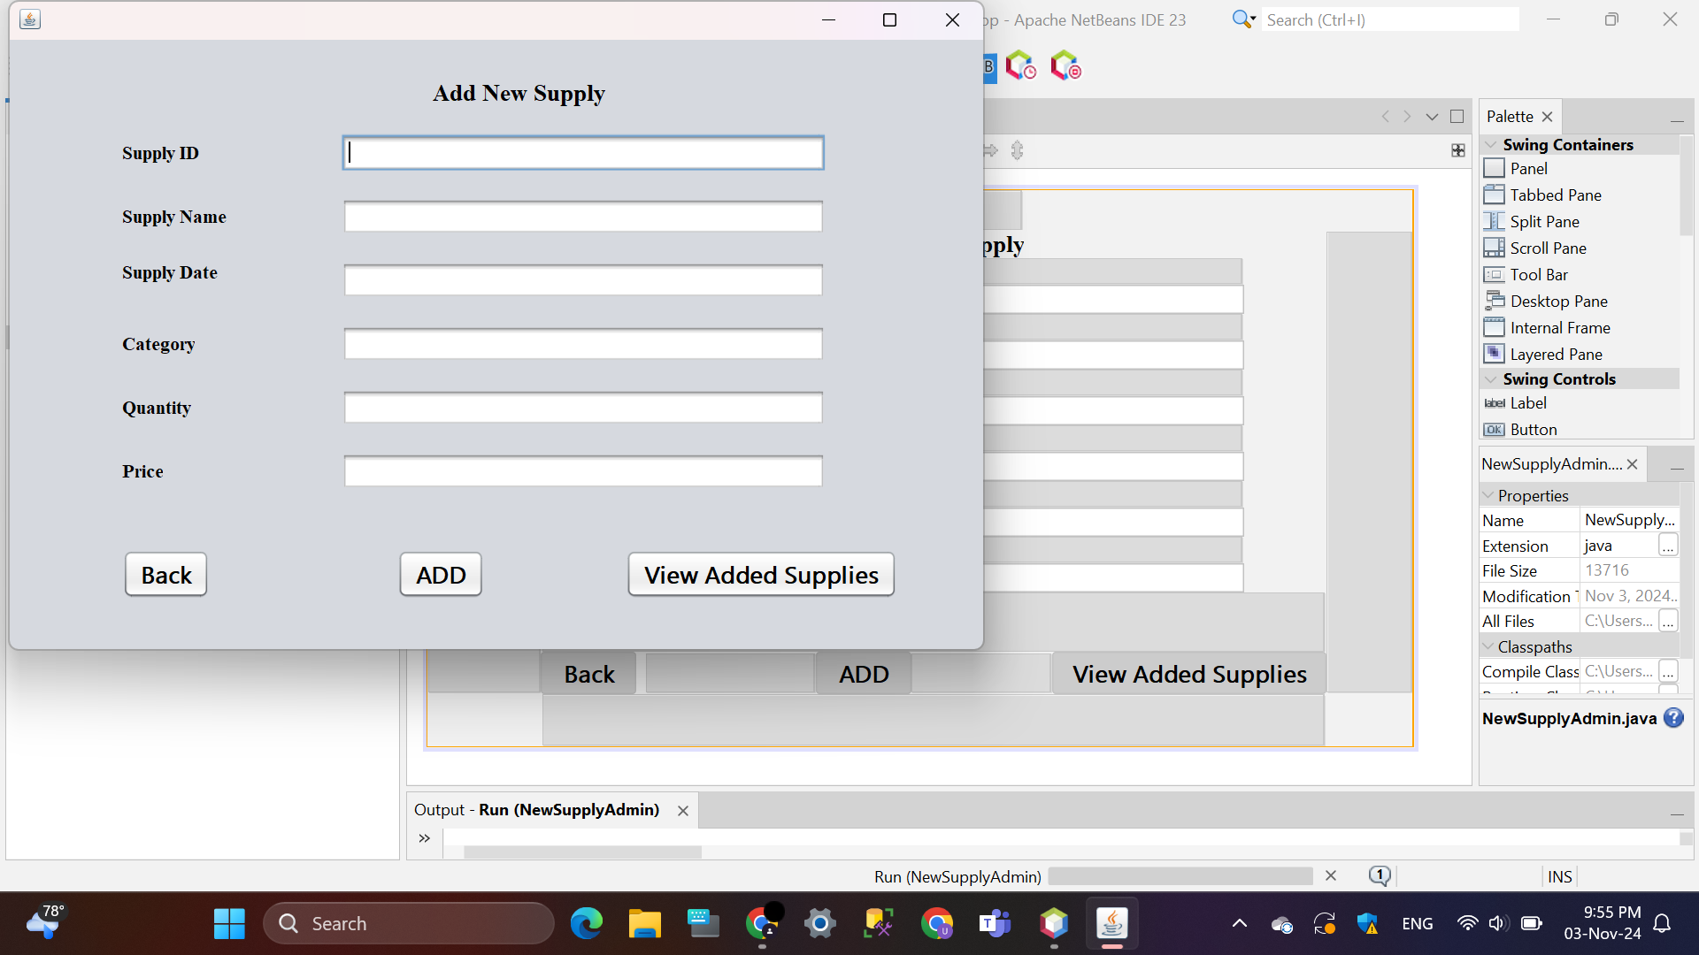**Manager**

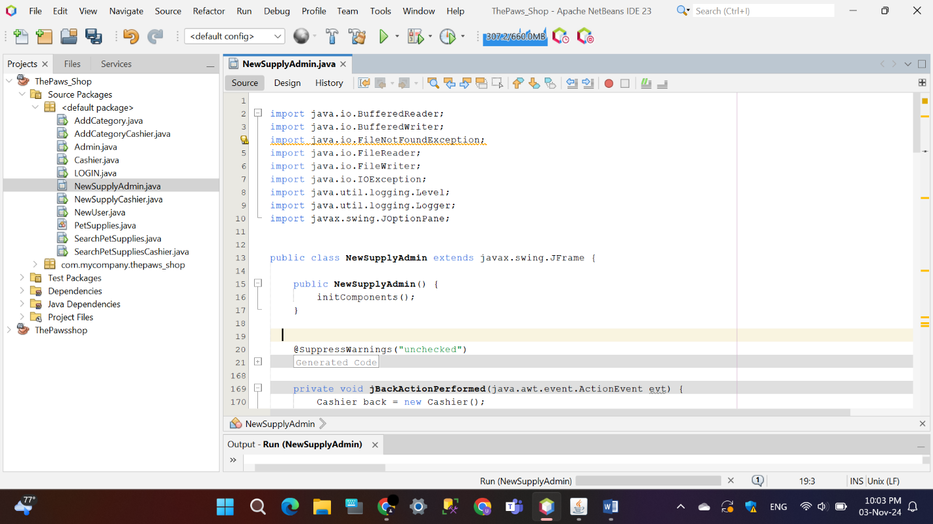

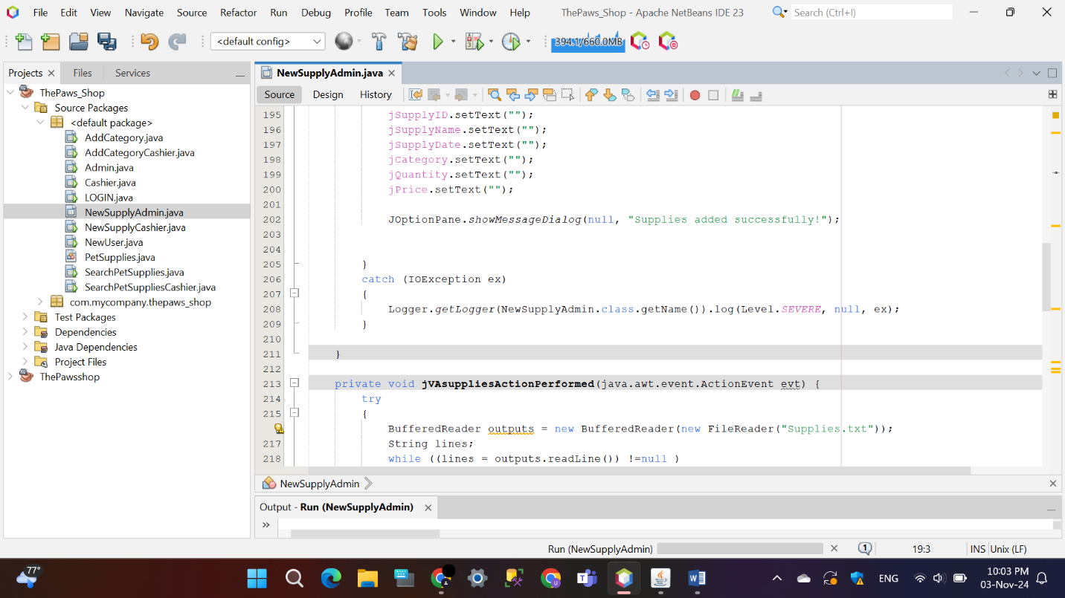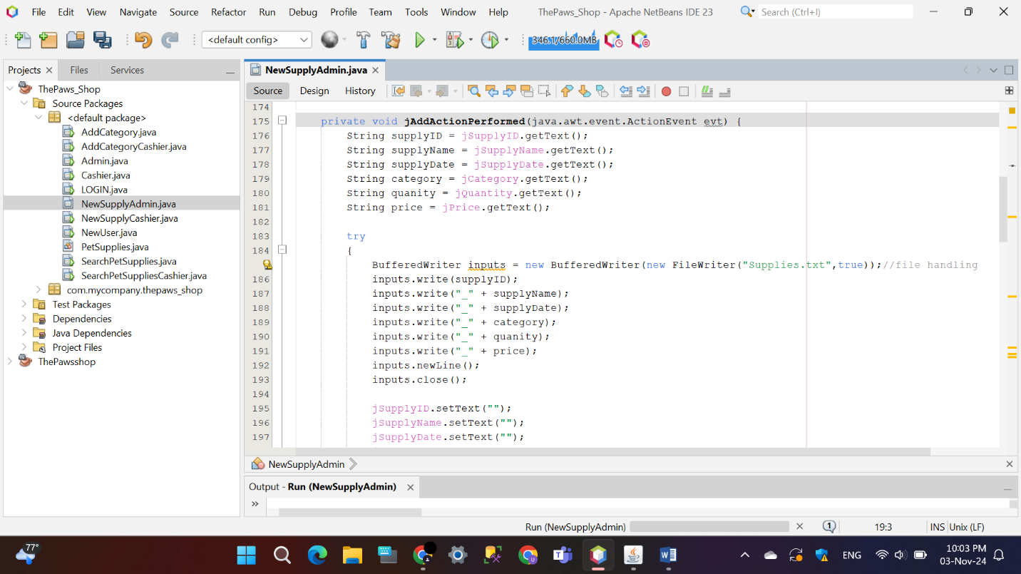

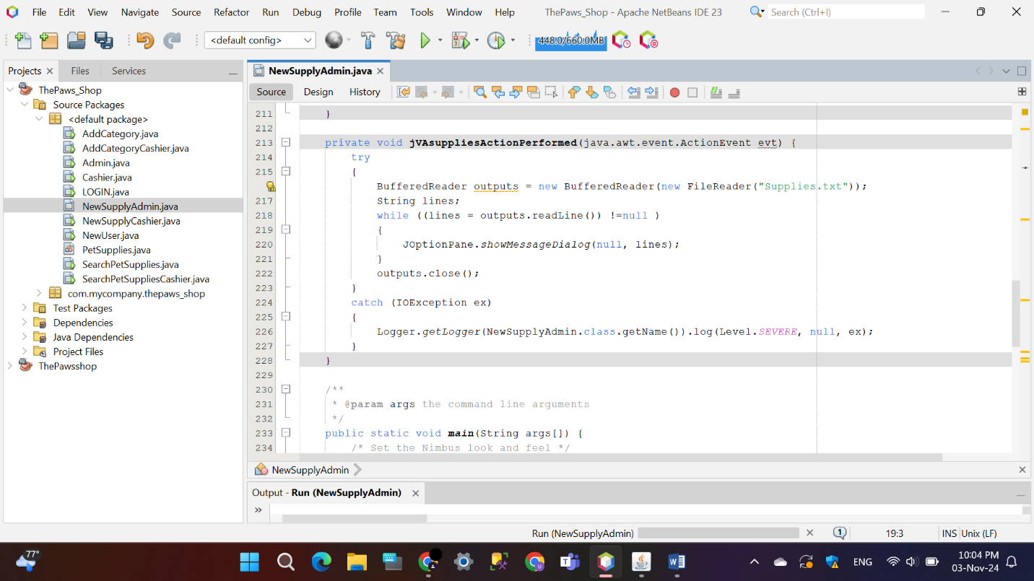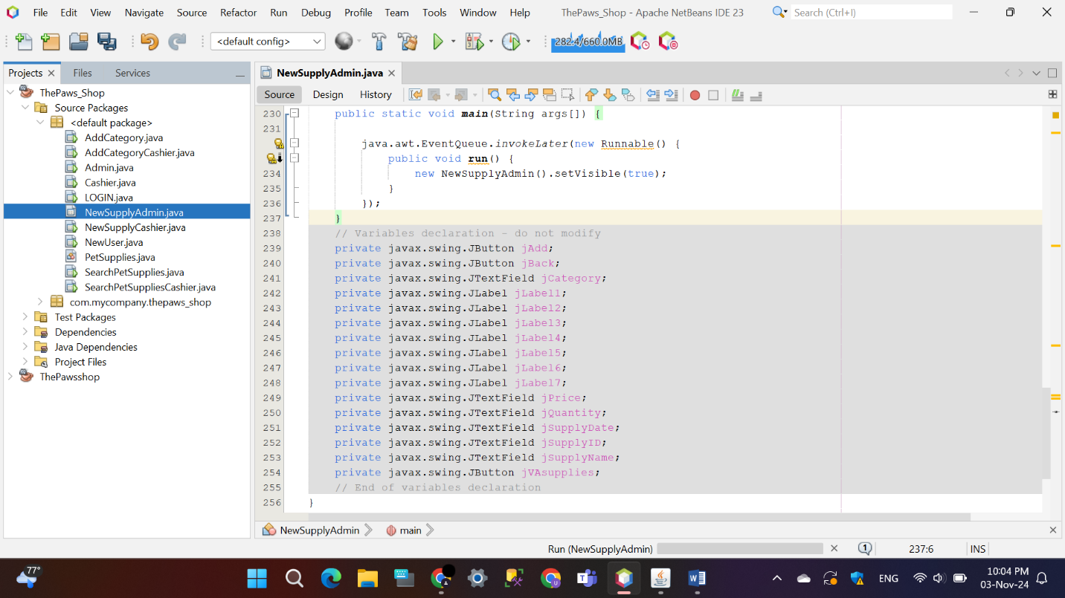

* **Cashier**

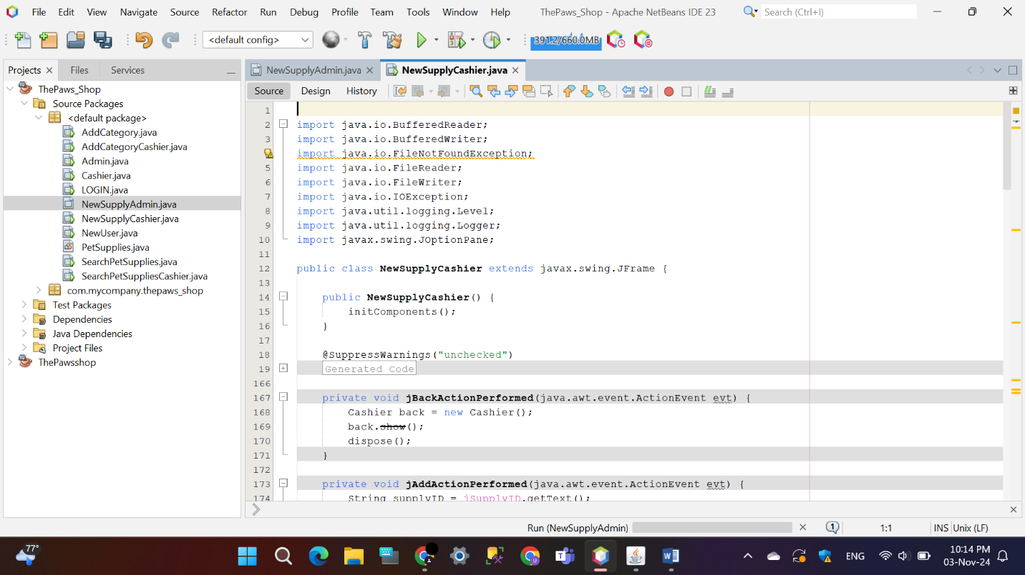

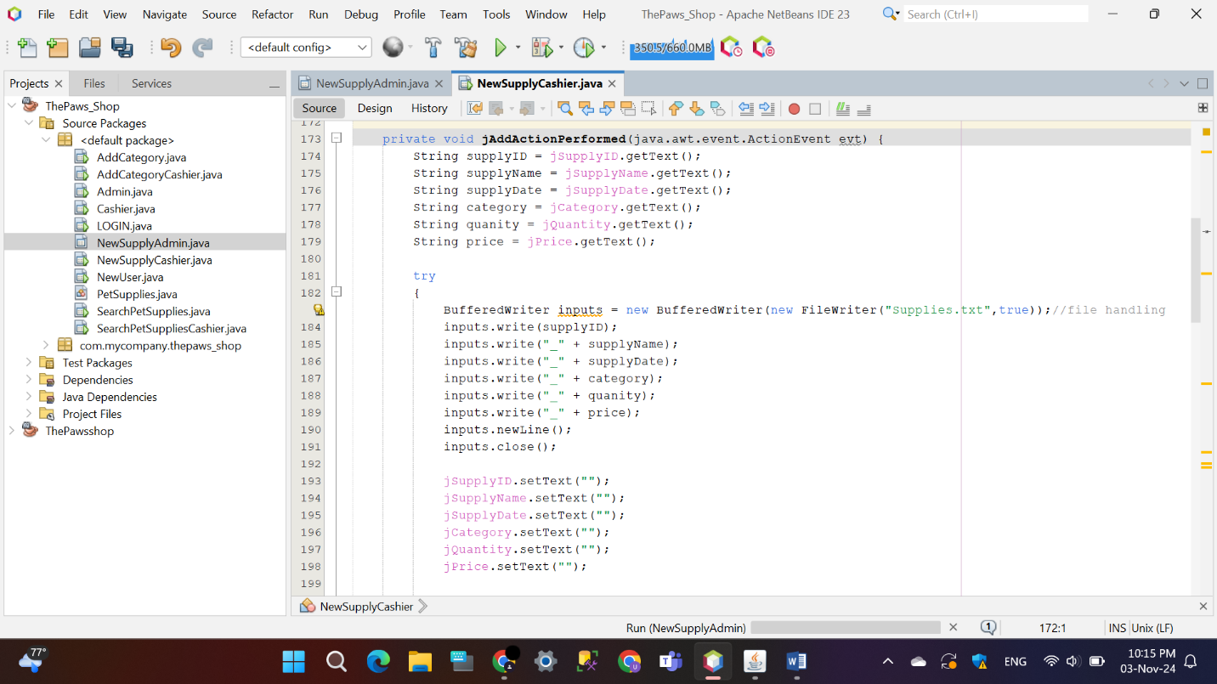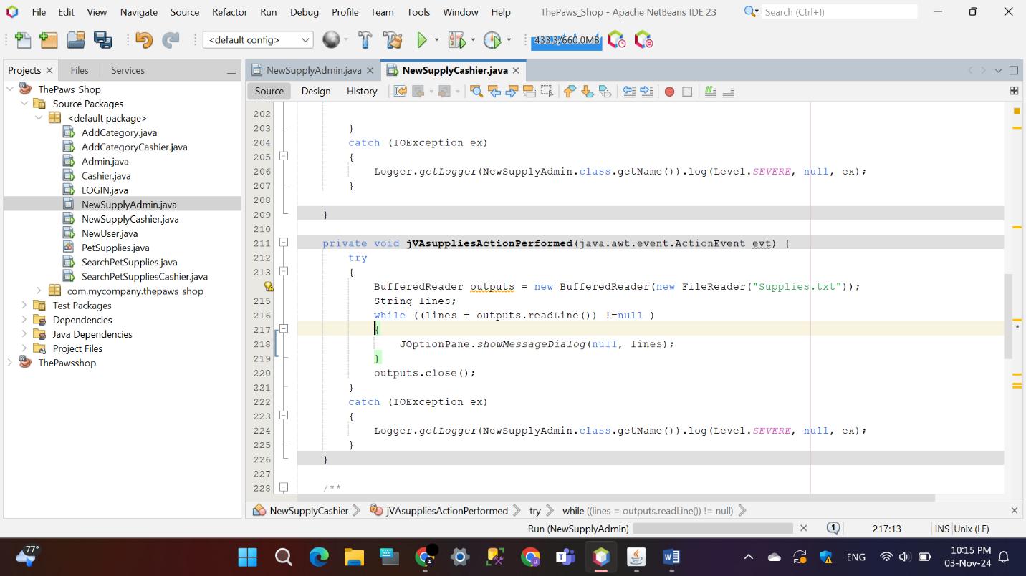

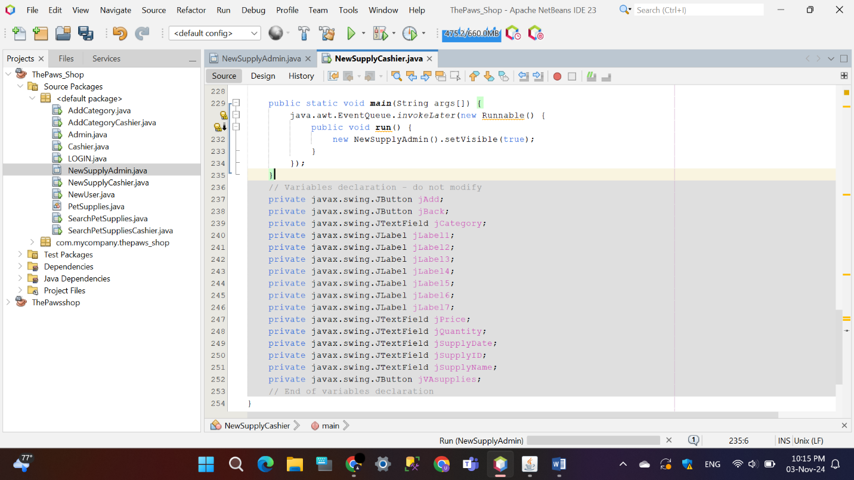

## Add Category

This Java Swing program creates a simple form for adding a category with up to three items. When the “ADD” button is clicked, it displays the entered data in a dialog box and clears the fields. The “Back” button returns to an ‘Admin’ or ‘Cashier’ screen.

* 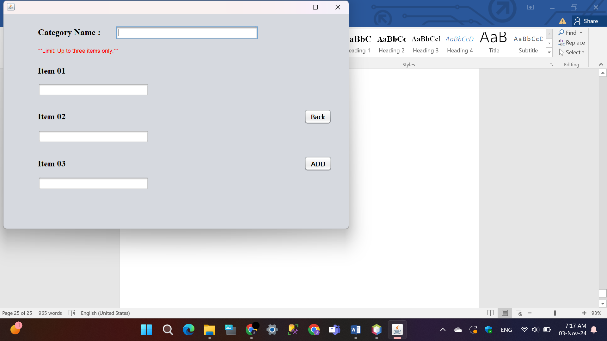**Manager**

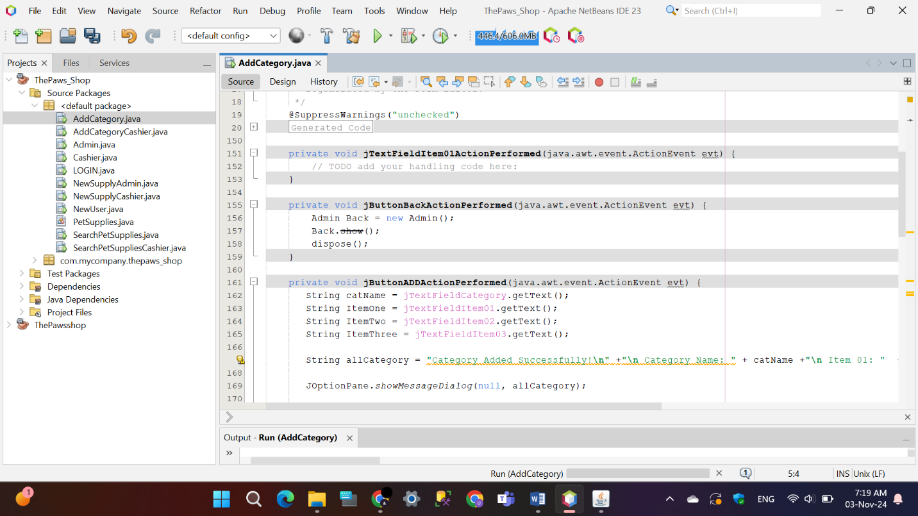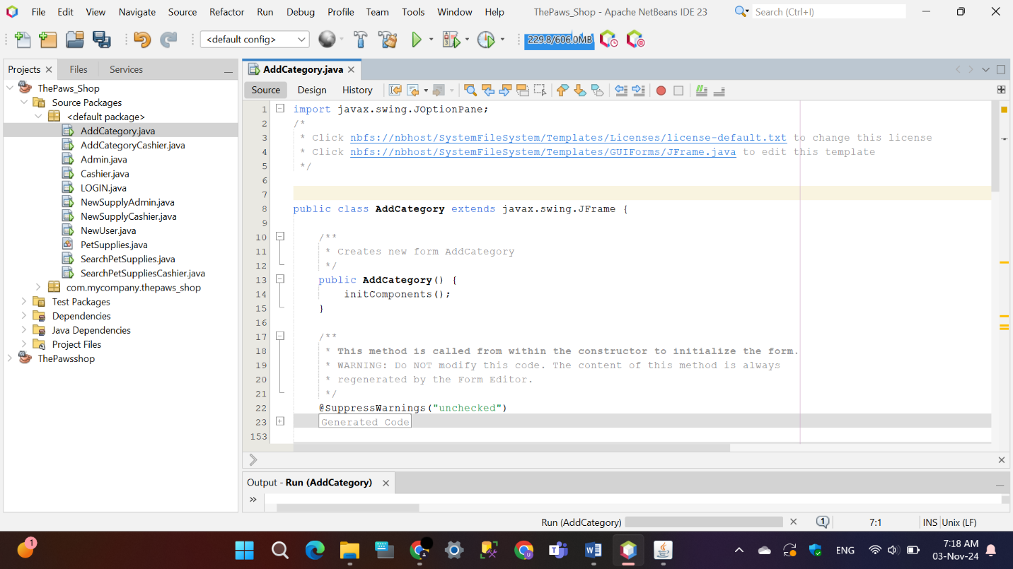

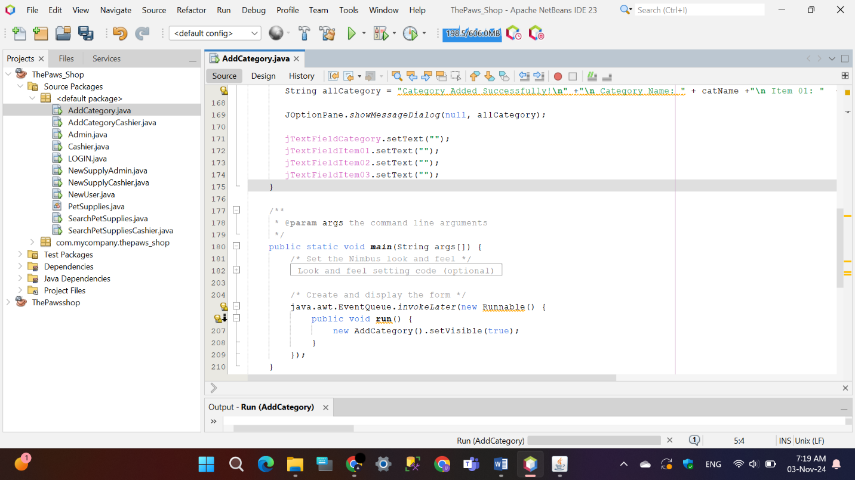

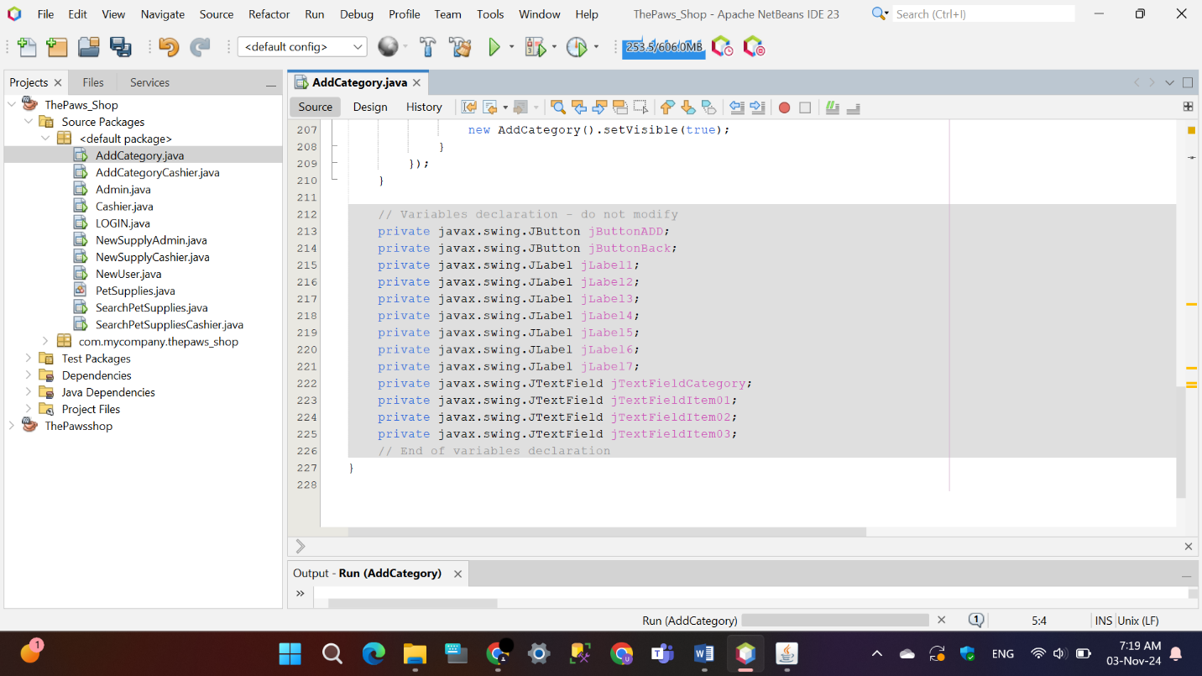

* 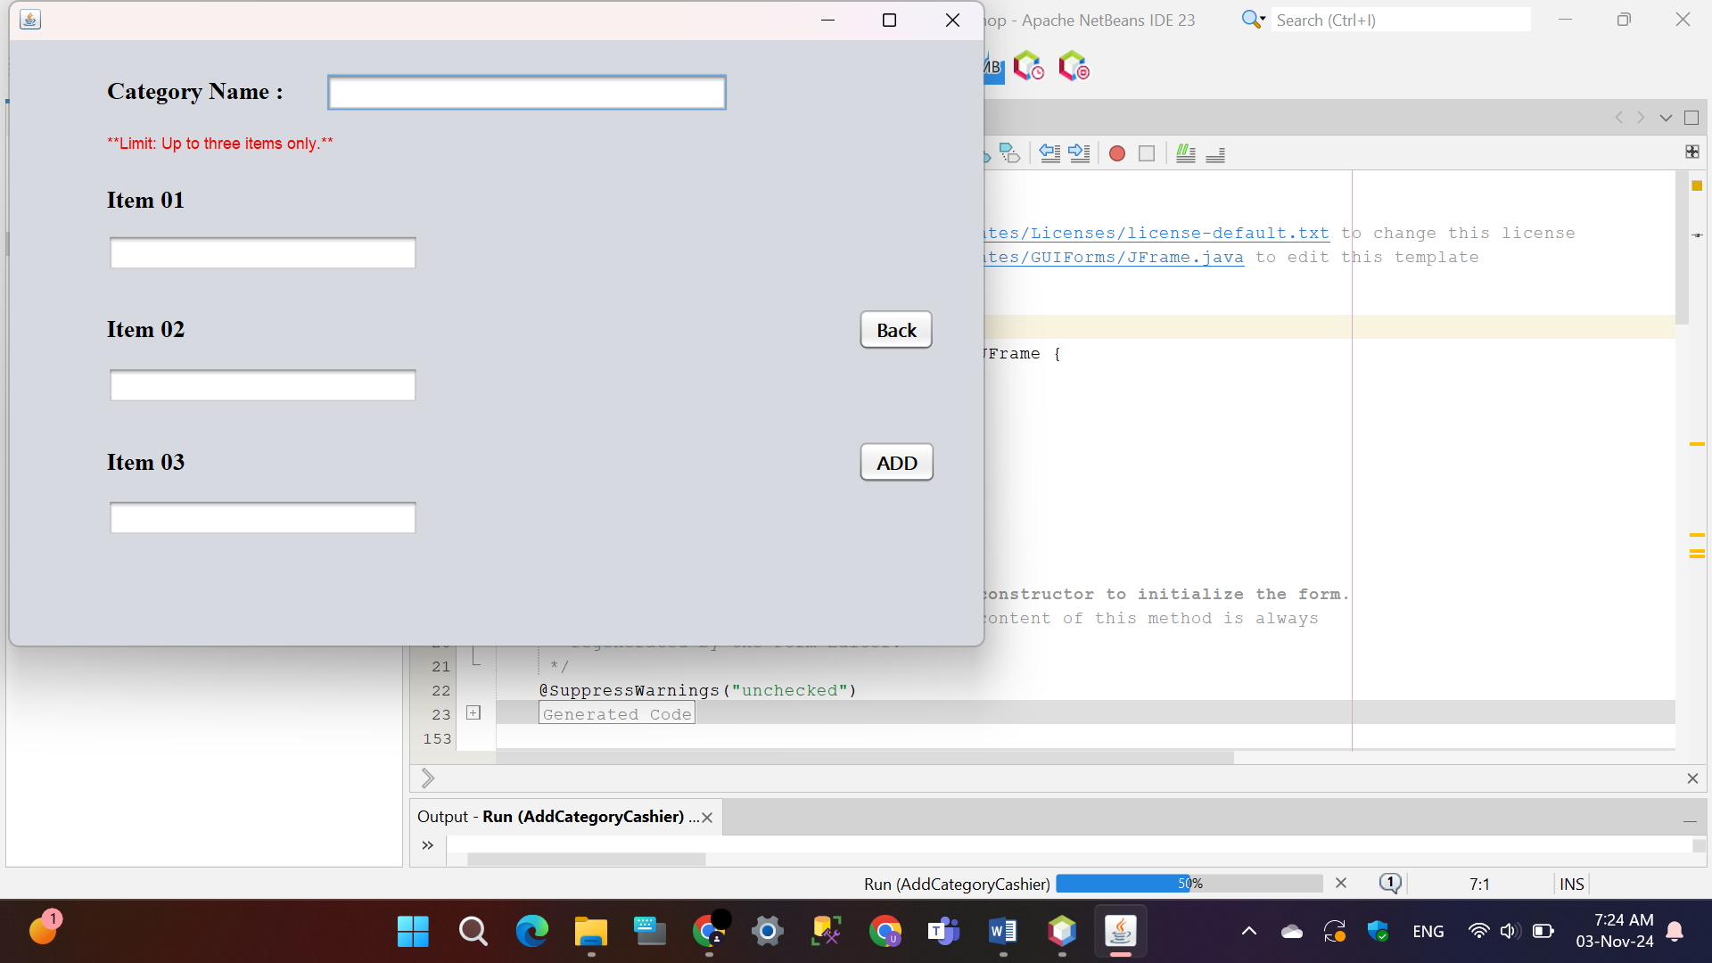**Cashier**

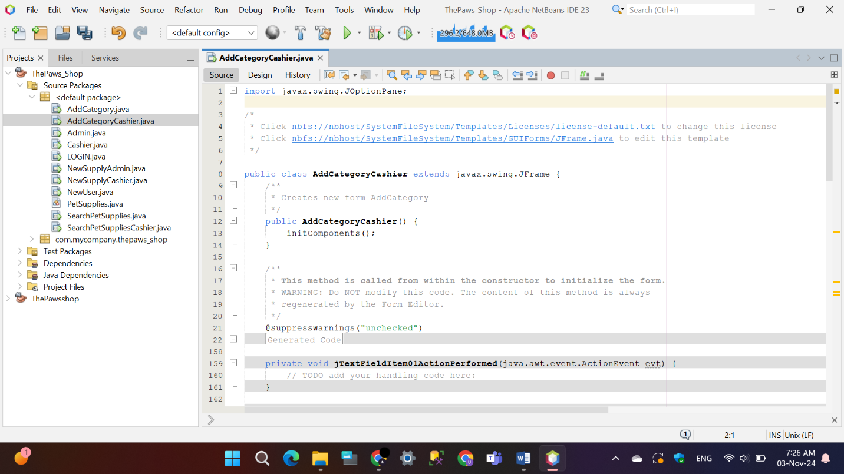

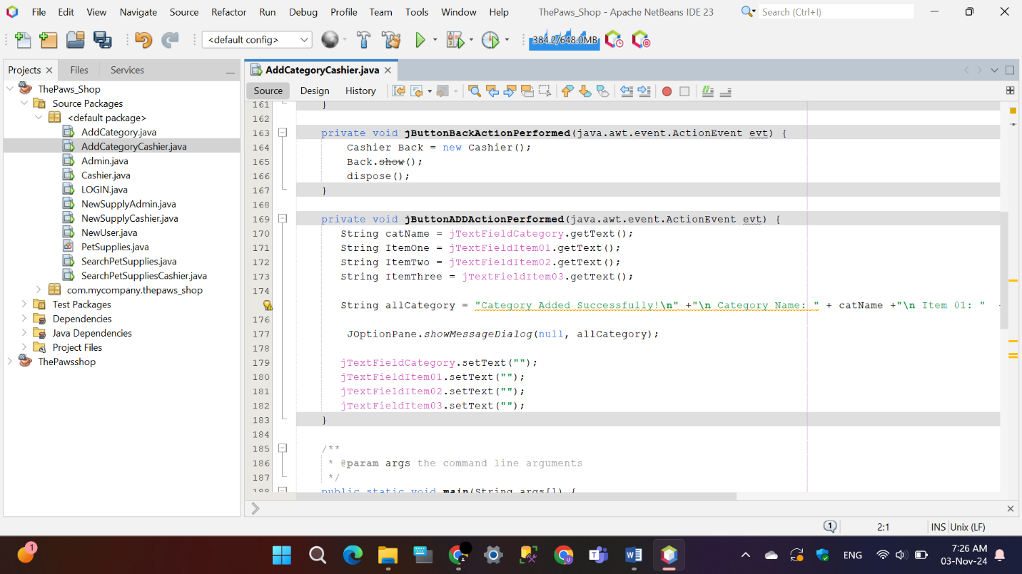

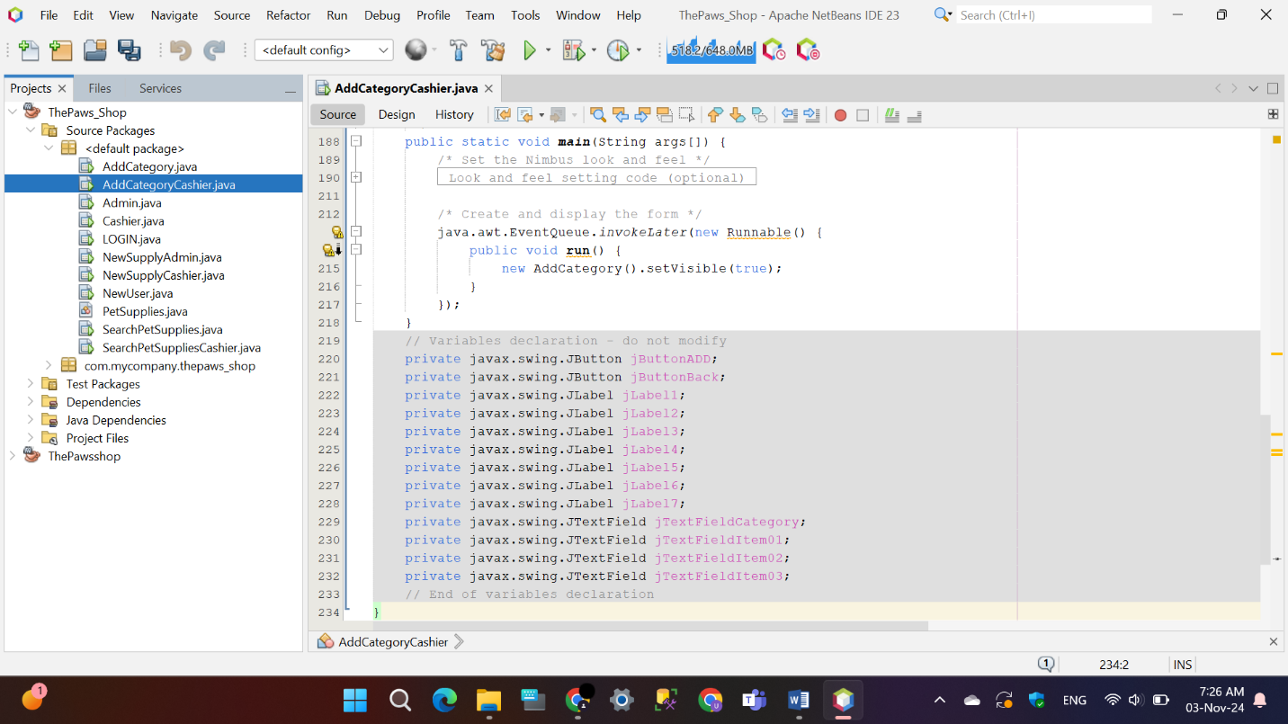

## Search Pet Supplies

The ‘SearchPetSupplies’ application is a simple Java Swing program that allows users to search for pet supplies by category. Users type an item name into a text field and click the “Search” button. The program checks if the item exists in a list of supplies, showing a message if it’s found or not. It also includes a “Back” button to return to the previous screen. This app uses a basic interface with labels, text fields, and buttons, making it easy to search for items in the list.

* 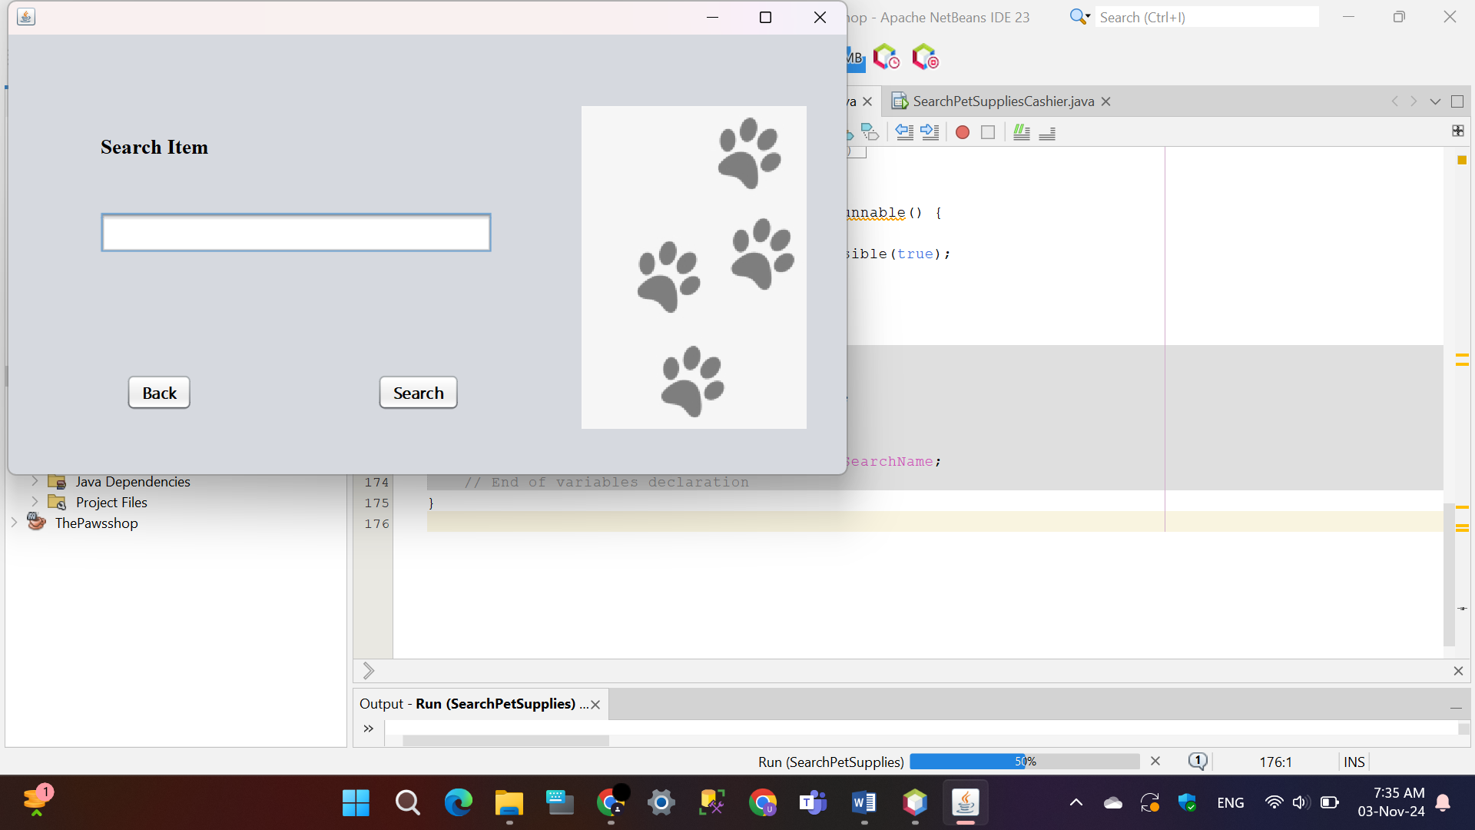**Manager**

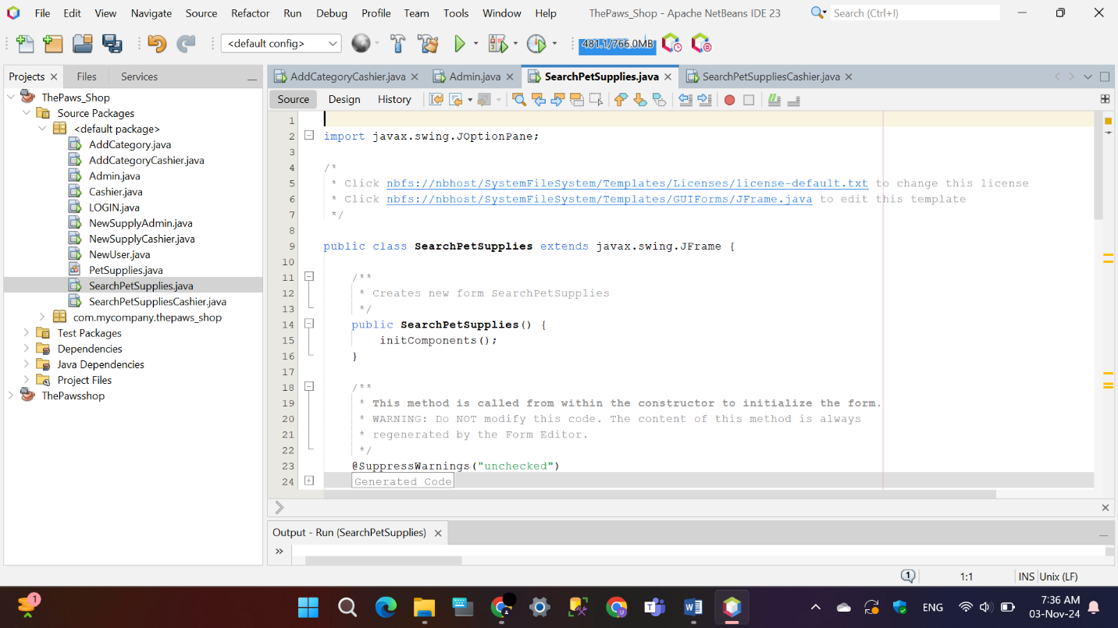

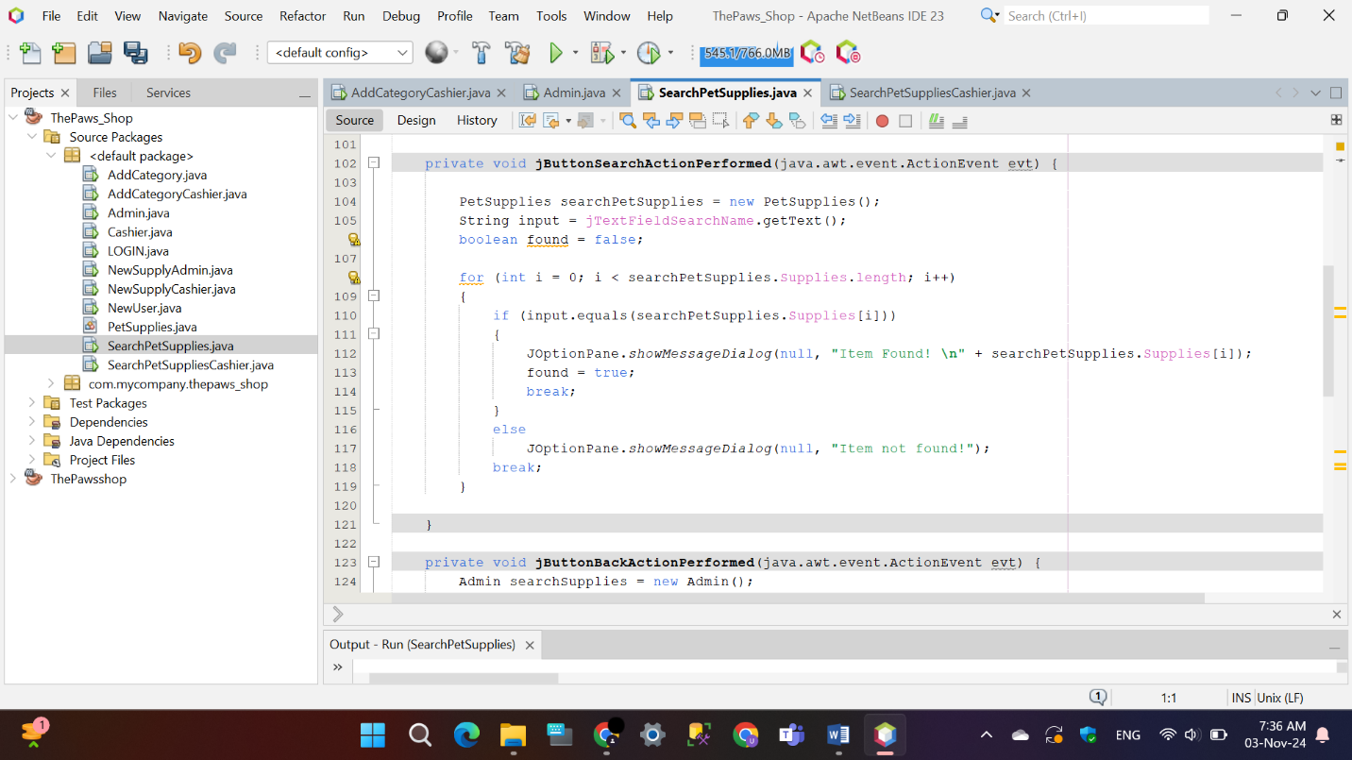

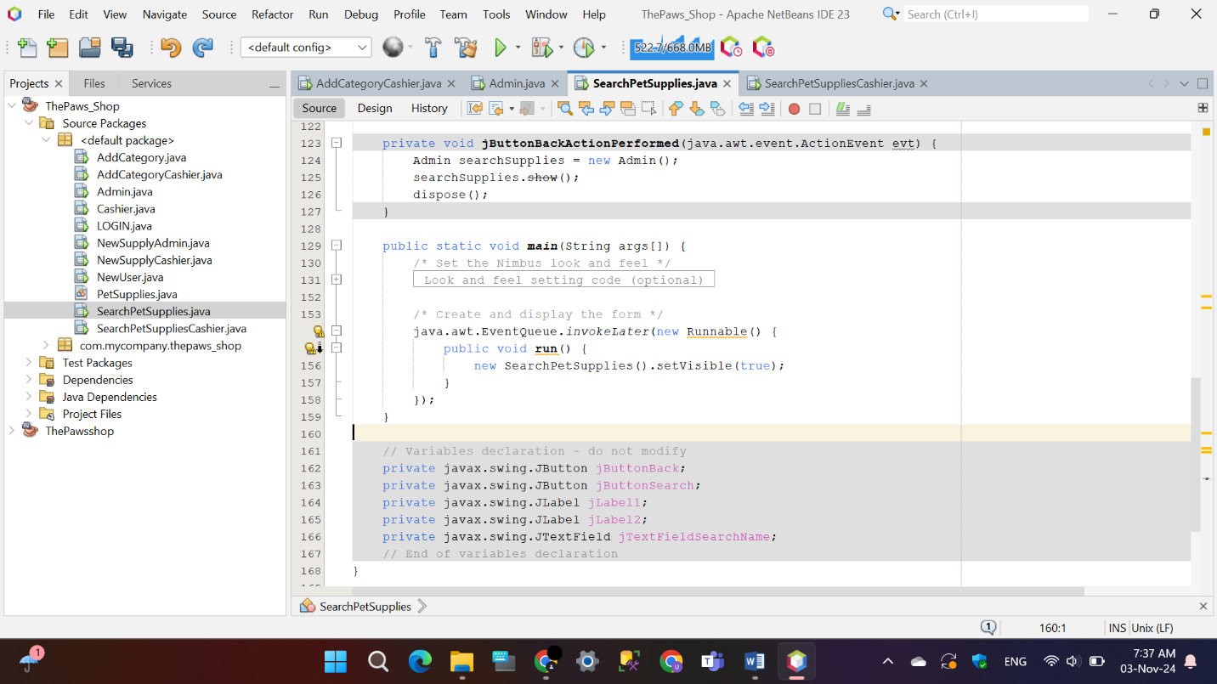

* **Cashier**



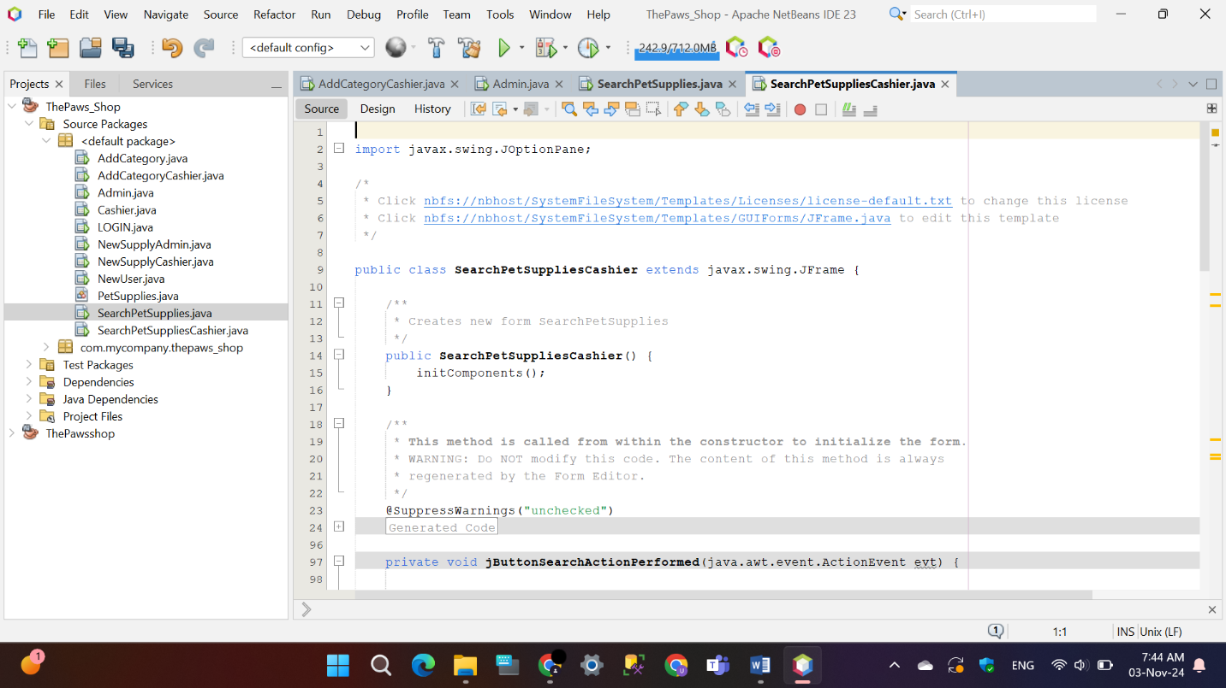

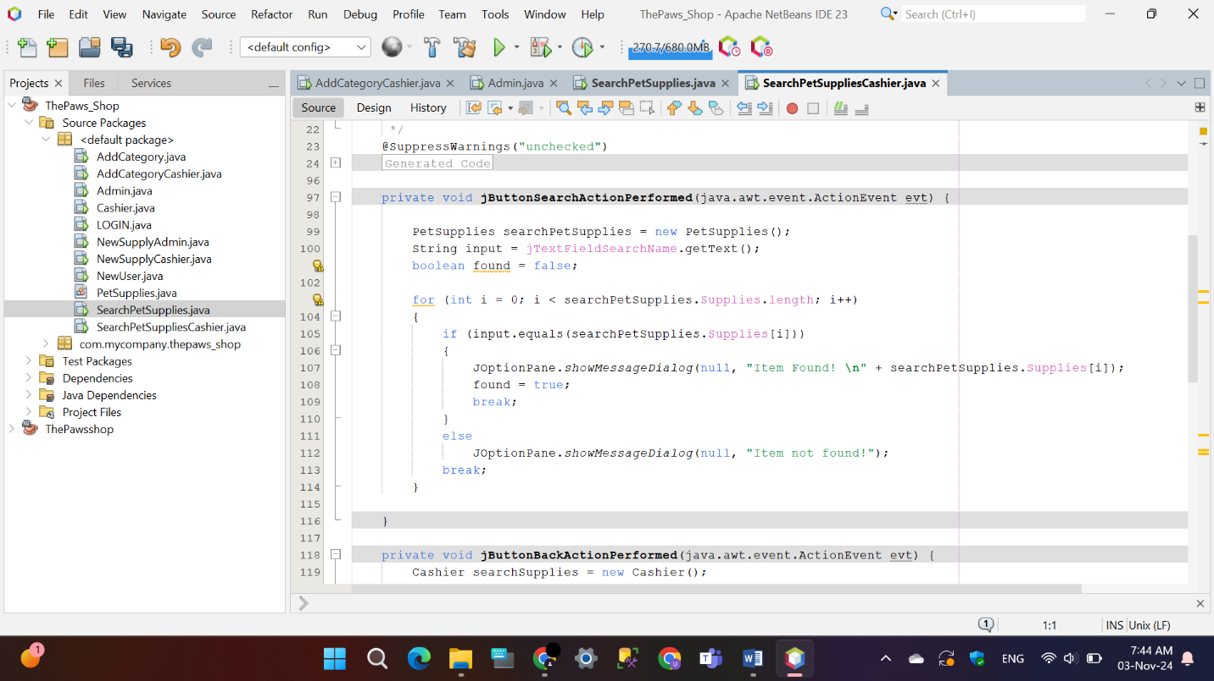

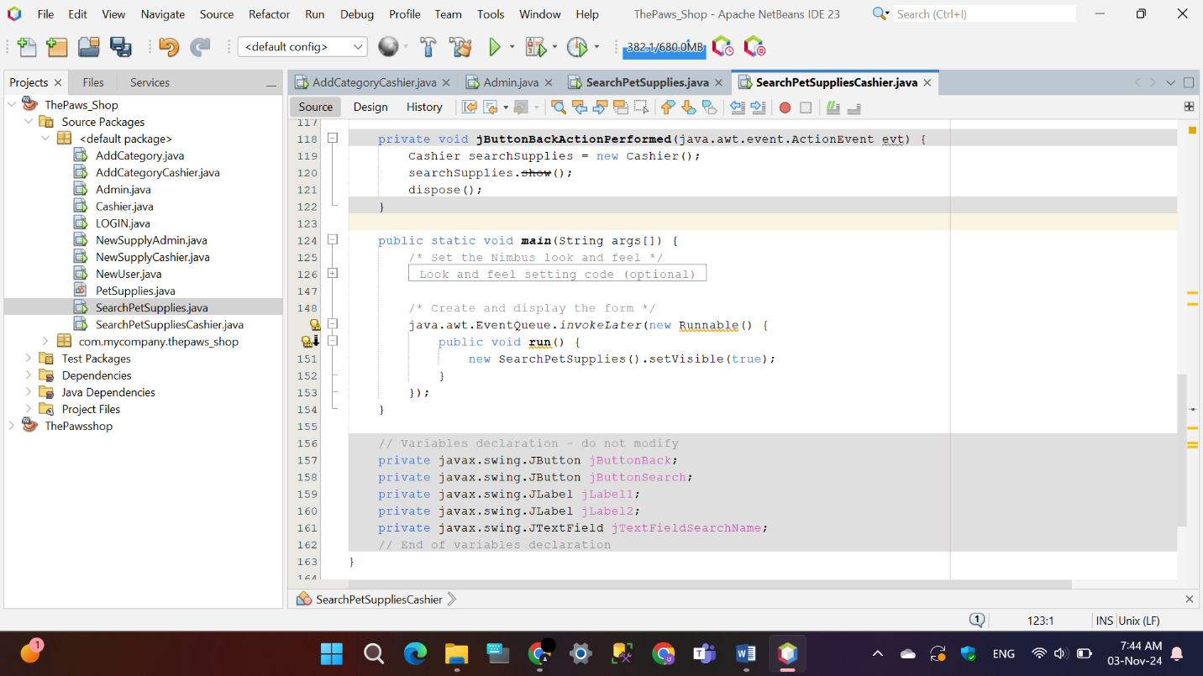

## Add New Cashier

The Java Swing application ‘NewUser’ enables a manager to input information such as Cashier ID, name, phone number, address, and email to add a new cashier. Once the information is entered, the manager will select the “Add User” button, and the software will show a confirmation message including the entered details. In addition, there is a “Back” button available for going back to the previous screen. This feature can only be accessed by managers to make sure that only approved users are able to add new cashiers.

* 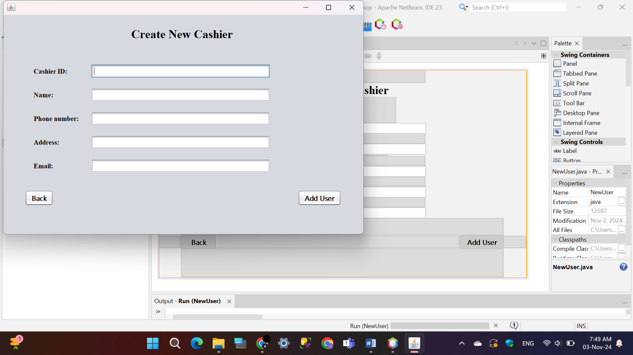**Manager**

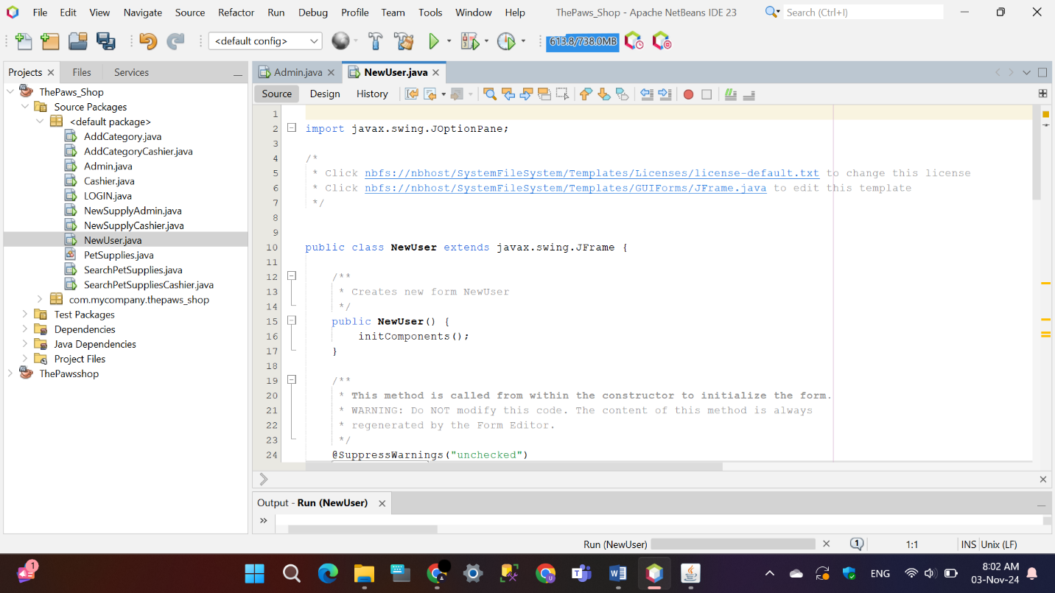

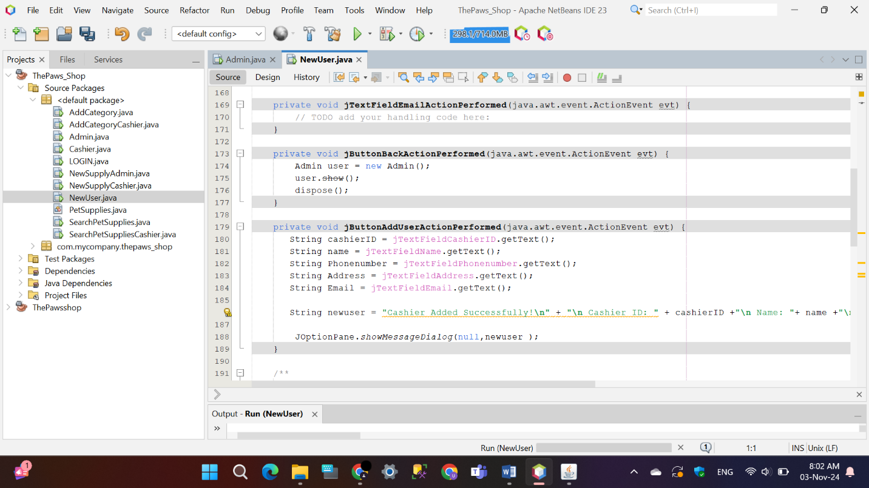

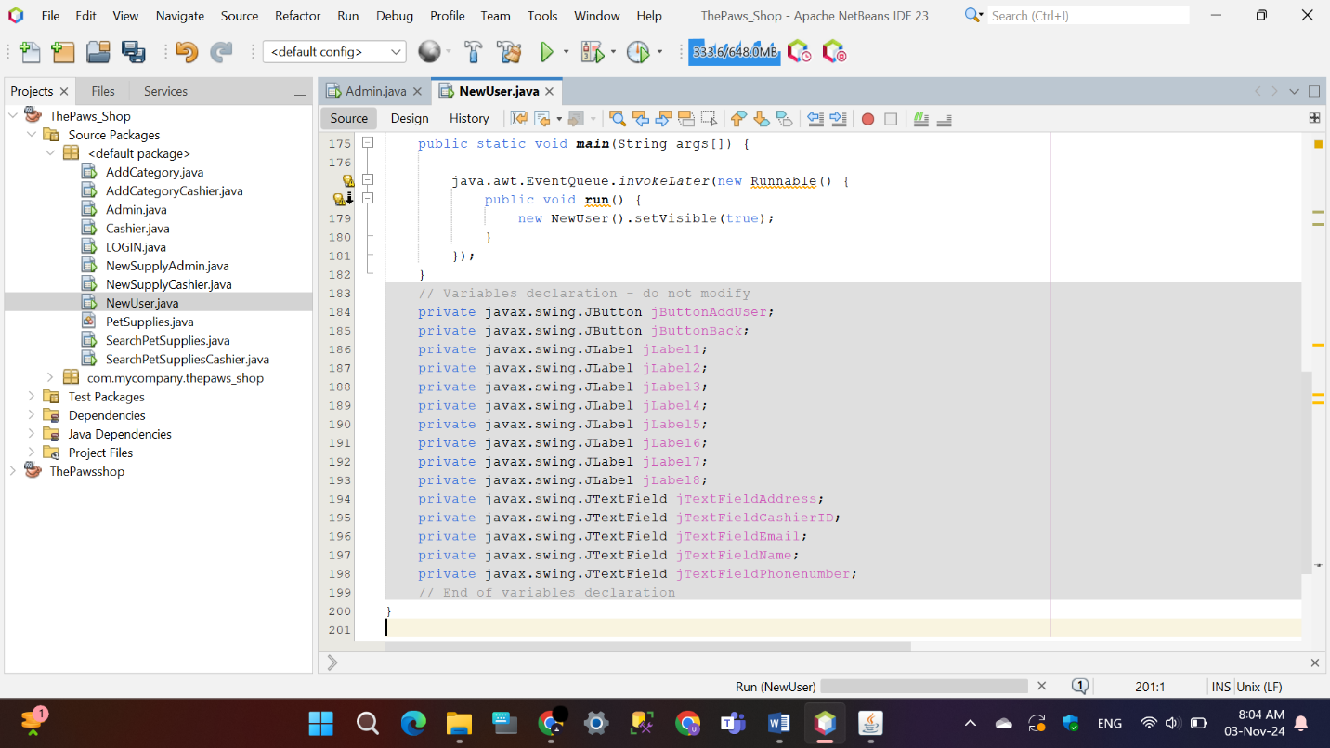

## Object Oriented Concepts

* **Object**

An object is an individual instance of a class, containing both data (attributes) and behaviors (methods). Objects represent specific entities with distinct characteristics, enabling the modeling of real-world items within a program.

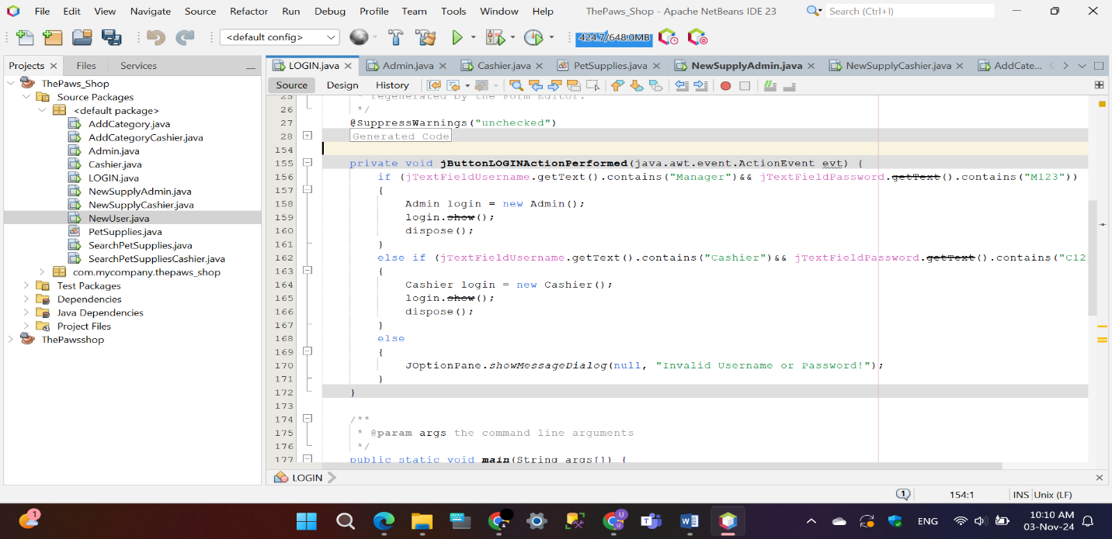Examples:

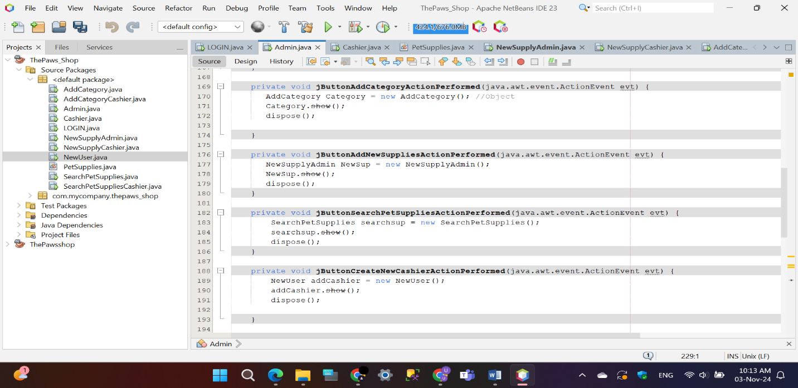

* **Class**

A class is a blueprint in programming that outlines the structure and actions of objects. It defines the properties (attributes) and behaviors (methods) that objects created from it will have. By using a class, you ensure that similar objects are built consistently and can perform the same functions.

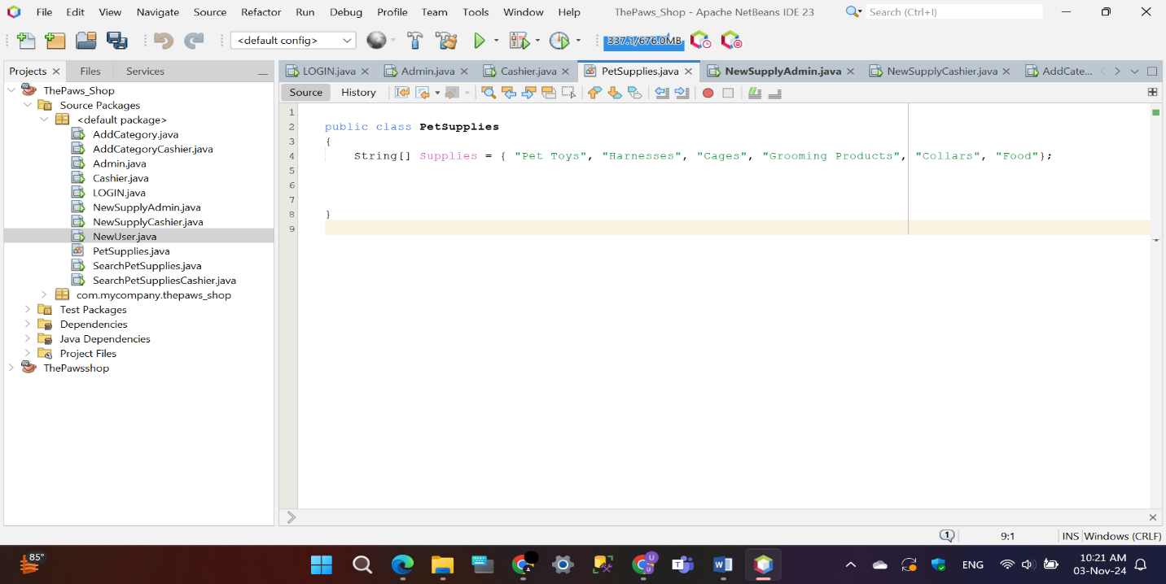Examples:

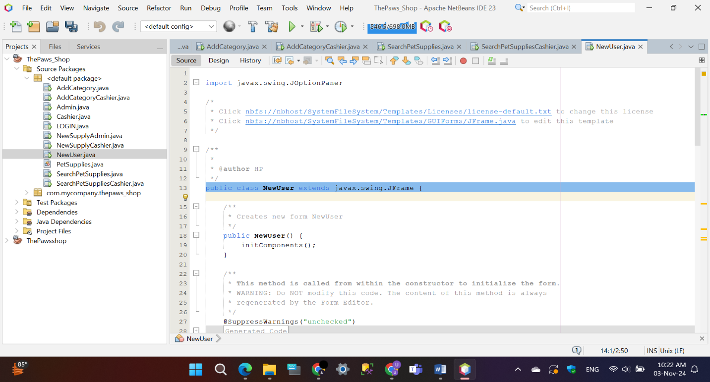

* **Abstractions**

Abstraction is the principle of hiding complex details and only exposing the essential features of an object. It allows users to interact with an object’s basic functionality without needing to understand or manage intricate underlying mechanisms, making interaction simpler and more intuitive.

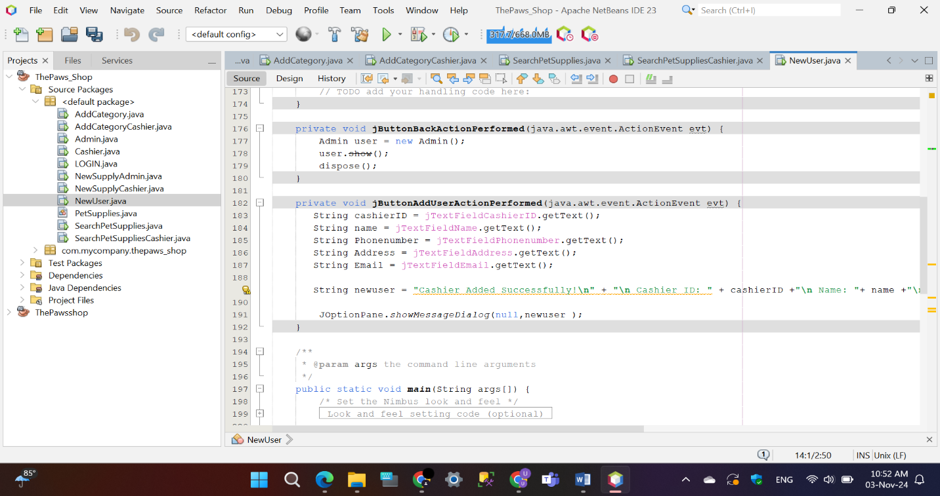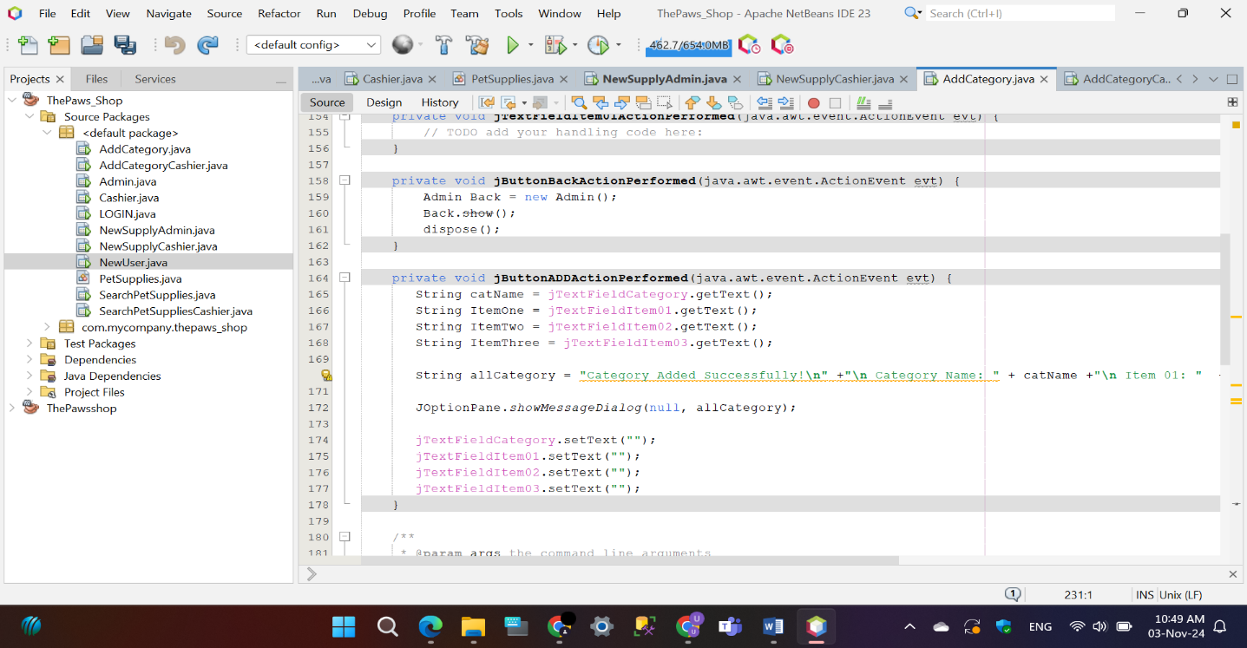Examples:

* **Inheritance**

Inheritance is a mechanism that allows a new class to inherit properties and methods from an existing class. This promotes code reusability and creates a hierarchical relationship between classes, where the new class can extend or modify the functionality of the inherited class as needed.

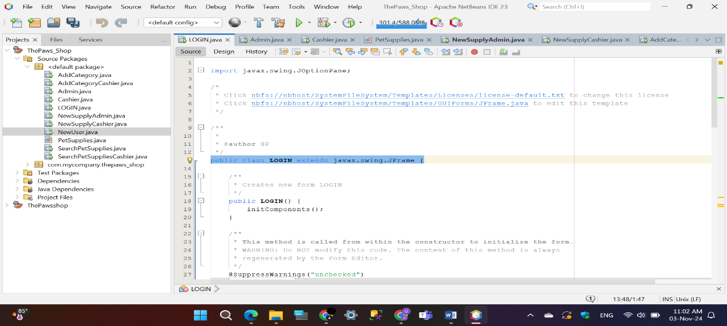Examples:

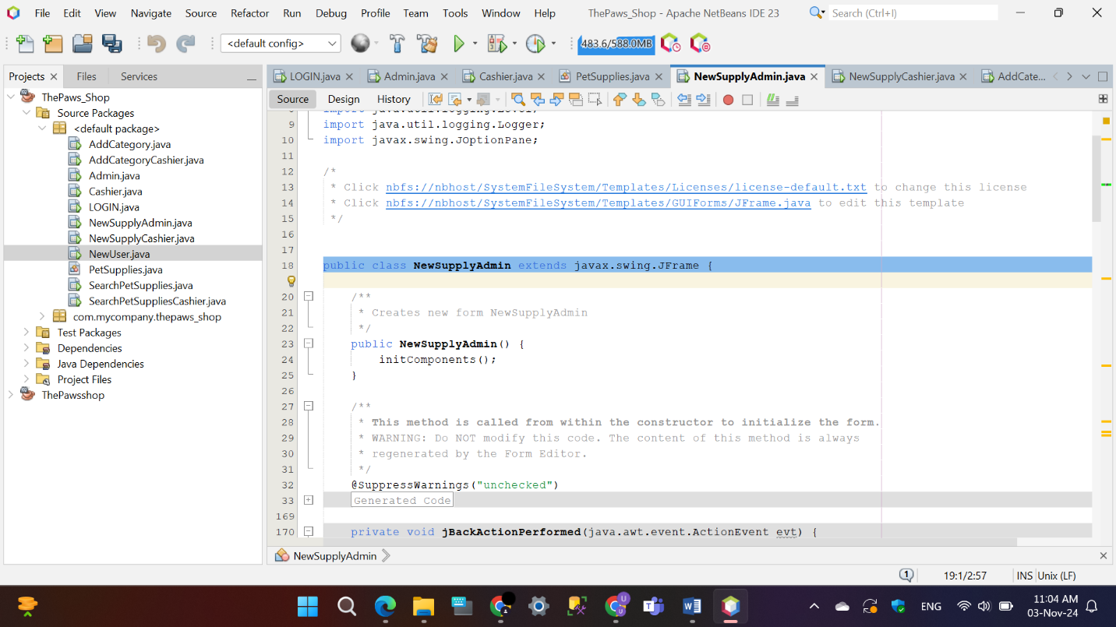

* **Encapsulation**

Encapsulation is the concept of bundling data and methods within a class and restricting access to specific components. This approach protects the integrity of the data by allowing controlled interaction through designated methods, maintaining a clear boundary between an object’s internal state and external interaction.

Example:

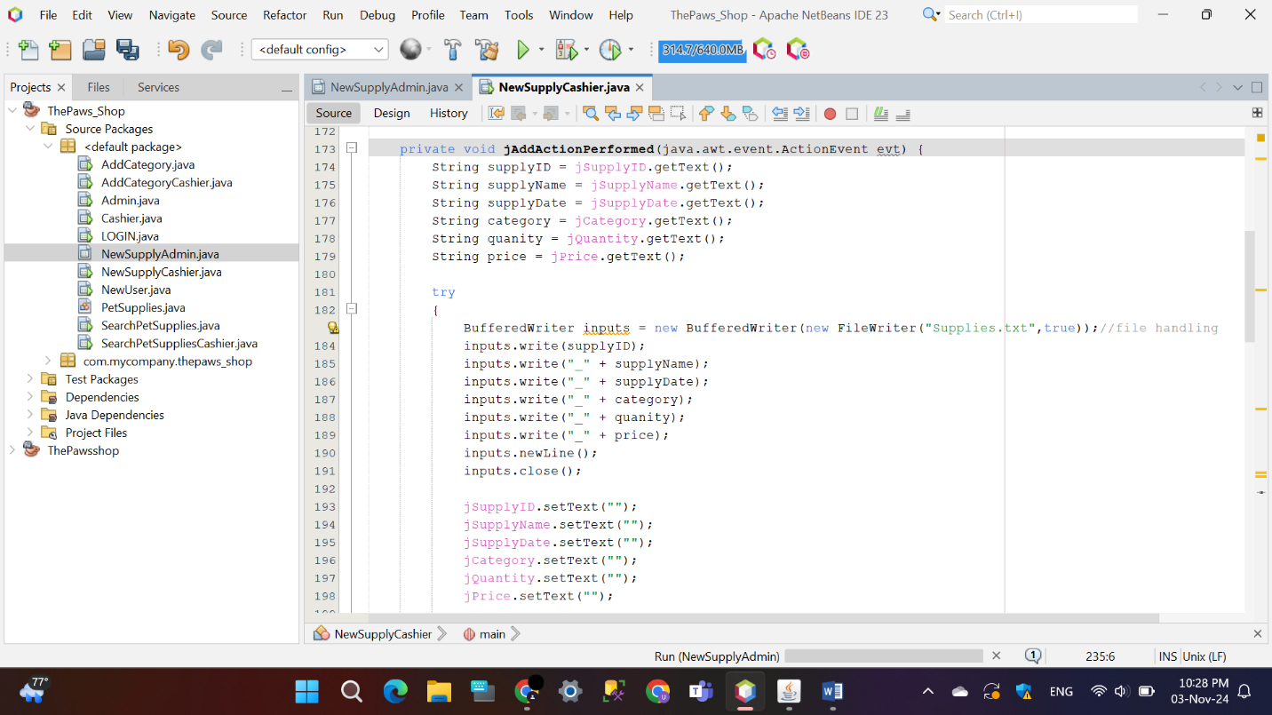

* **Polymorphism**

Polymorphism is the ability of different objects to respond uniquely to the same method or operation. It allows for flexibility and integration, as objects can be treated in a uniform way while each one behaves according to its specific implementation, enabling code that is more adaptable and scalable.

Example:

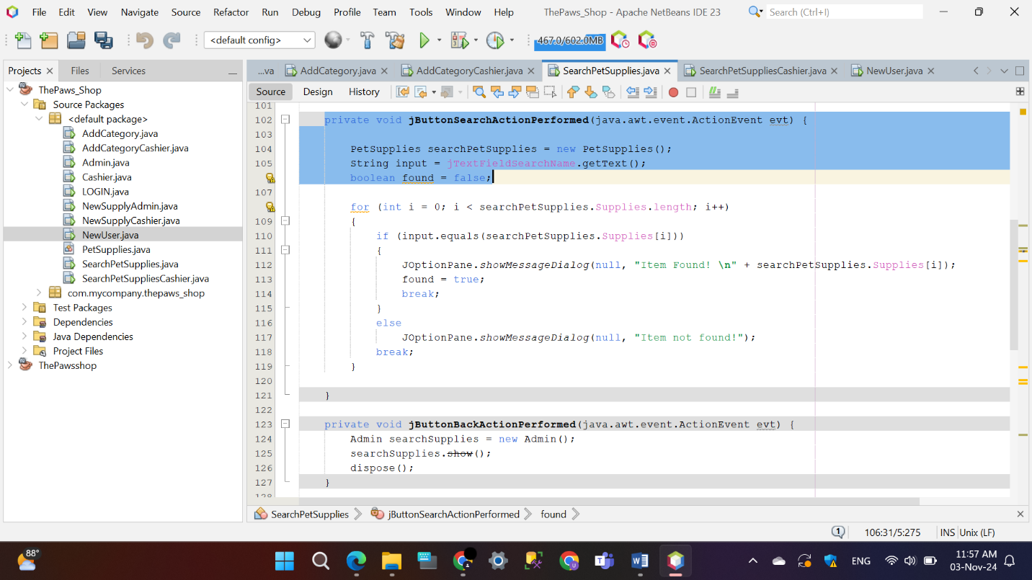

**User manual for manager and cashier.**

## Login Interface

This Java-based login application provides a secure entry system for a store named “The Paws Shop”. The login interface allows users to access different roles based on their credentials: “Manager” with password “M123” and “Cashier” with password “C123”. If the correct credentials are entered, the application opens a specific interface based on the user's role and closes the login screen. In case of incorrect credentials, an error message appears, informing users of an “Invalid Username or Password!” The application has a simple, clean interface with labels, icons, and a button for easy navigation, making it user-friendly and efficient for basic authentication purposes.

* **Manager**

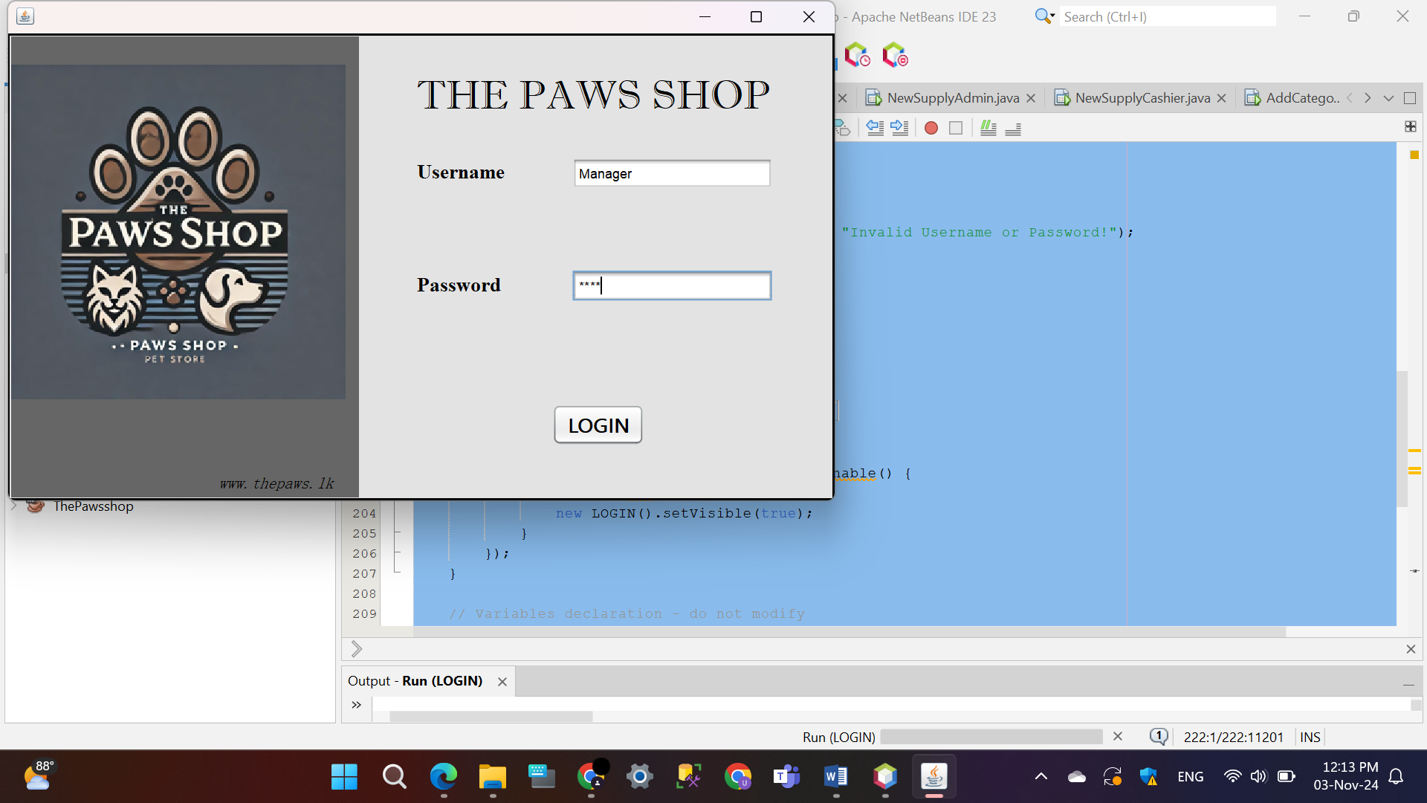Valid credentials

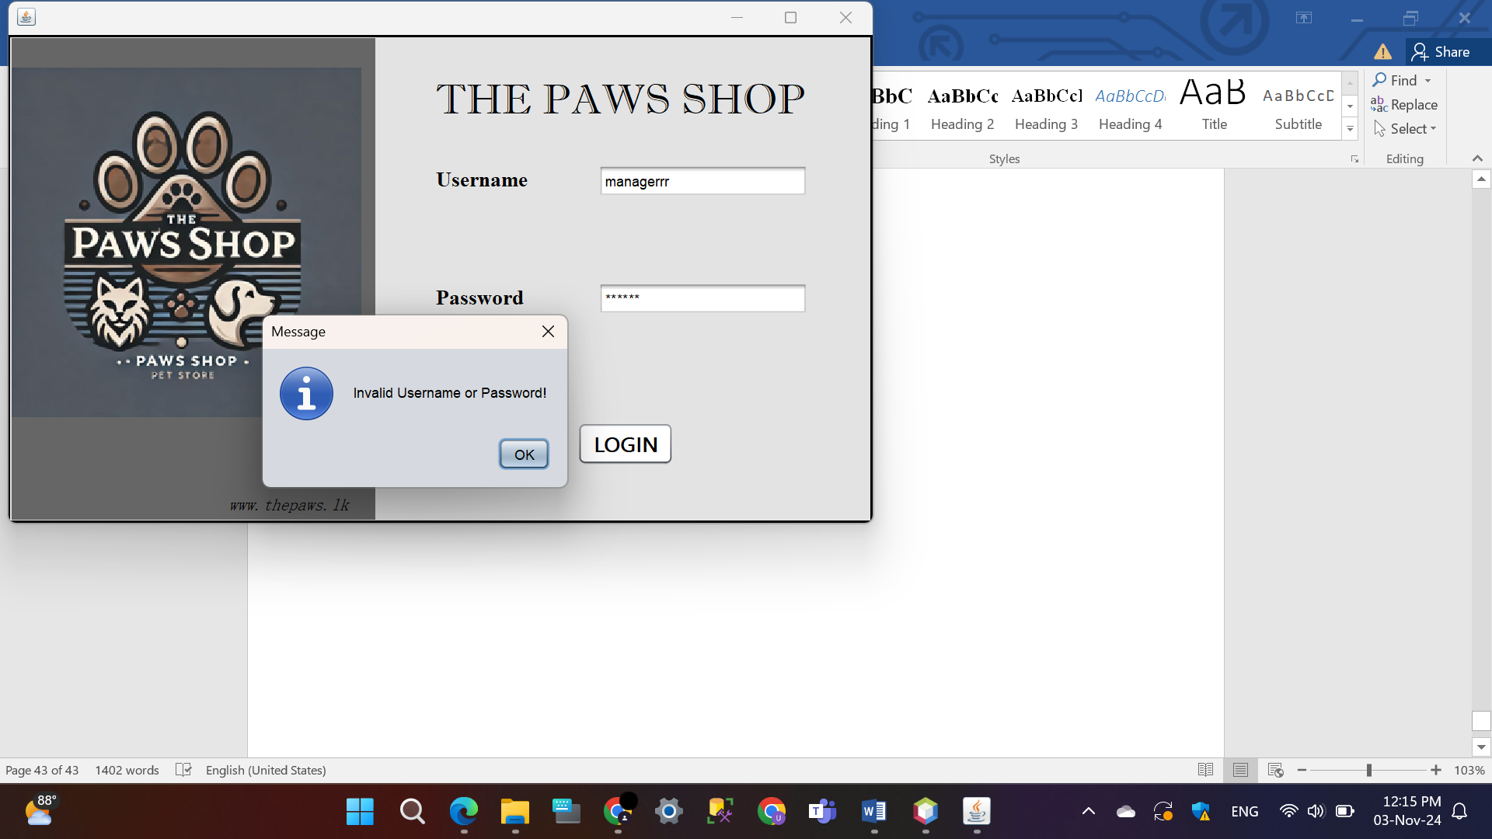Invalid credentials

* **Cashier**

Valid credential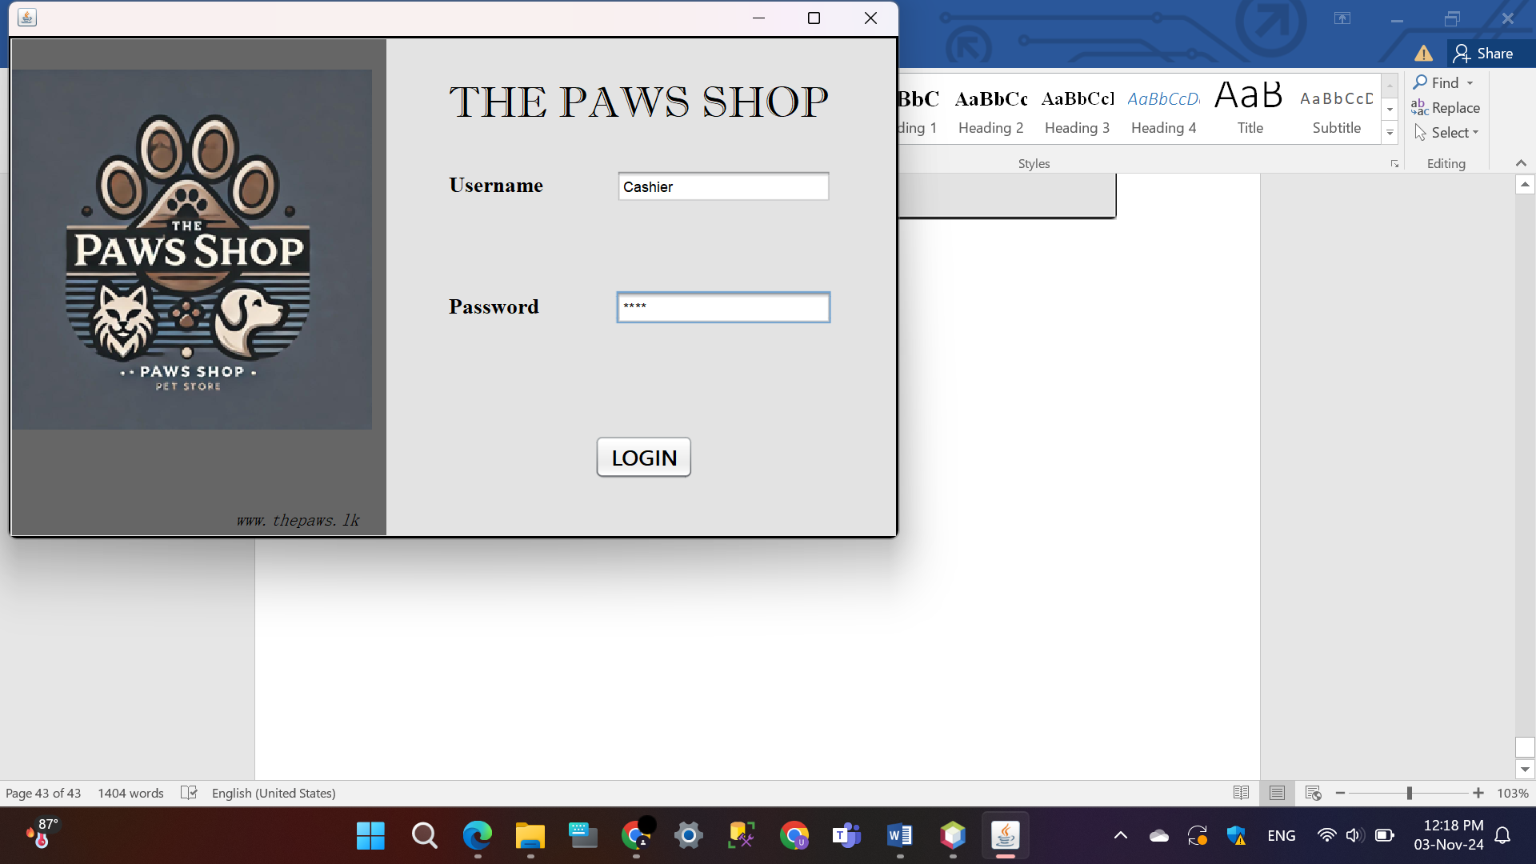s

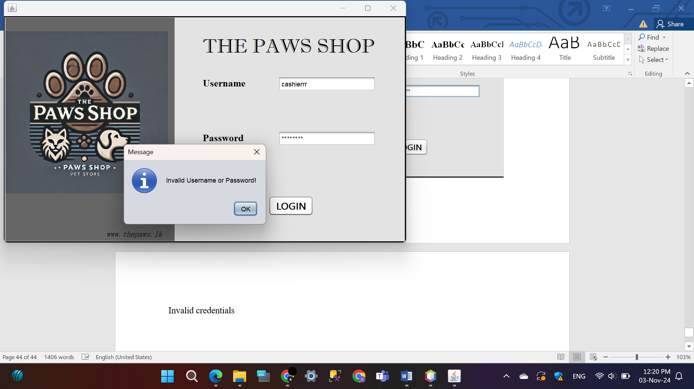Invalid credentials

## Main Menu Interface

The Admin and Cashier Main Menu applications provide user-friendly interfaces for managing a pet supplies store efficiently. The Admin Main Menu allows admins to view, add, and search pet supplies, create new cashiers, and add product categories, all accessible through dedicated buttons that open new windows for each function. Similarly, the Cashier Main Menu enables cashiers to view inventory, add new supplies, categorize products, and search for specific items, streamlining supply management. Both interfaces feature a “Logout” button for secure exit, making these applications simple, intuitive, and ideal for efficiently overseeing store operations.

* 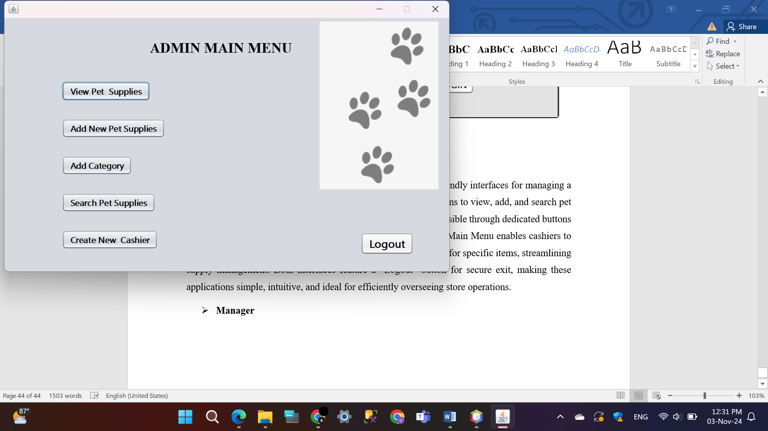**Manager**
* 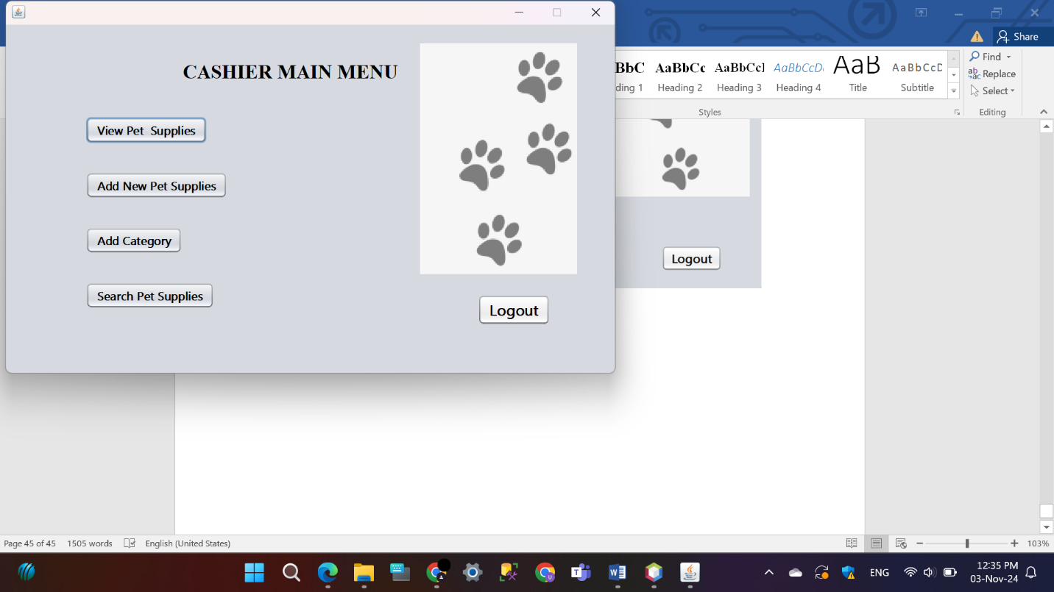**Cashier**

## View Pet Supplies

The Pet Supplies enables users to see a selection of pet supplies at the store. An array of items, such as pet toys, harnesses, cages, grooming products, collars, and food, is displayed in a dialog box when the user clicks the "View Pet Supplies" button. This uncomplicated and direct feature allows rapid retrieval of inventory details, helping cashiers and administrators to remain updated on the items ready for purchase. The interface, which is easy for users to navigate, allows them to effectively oversee and handle pet supplies in the store.

* 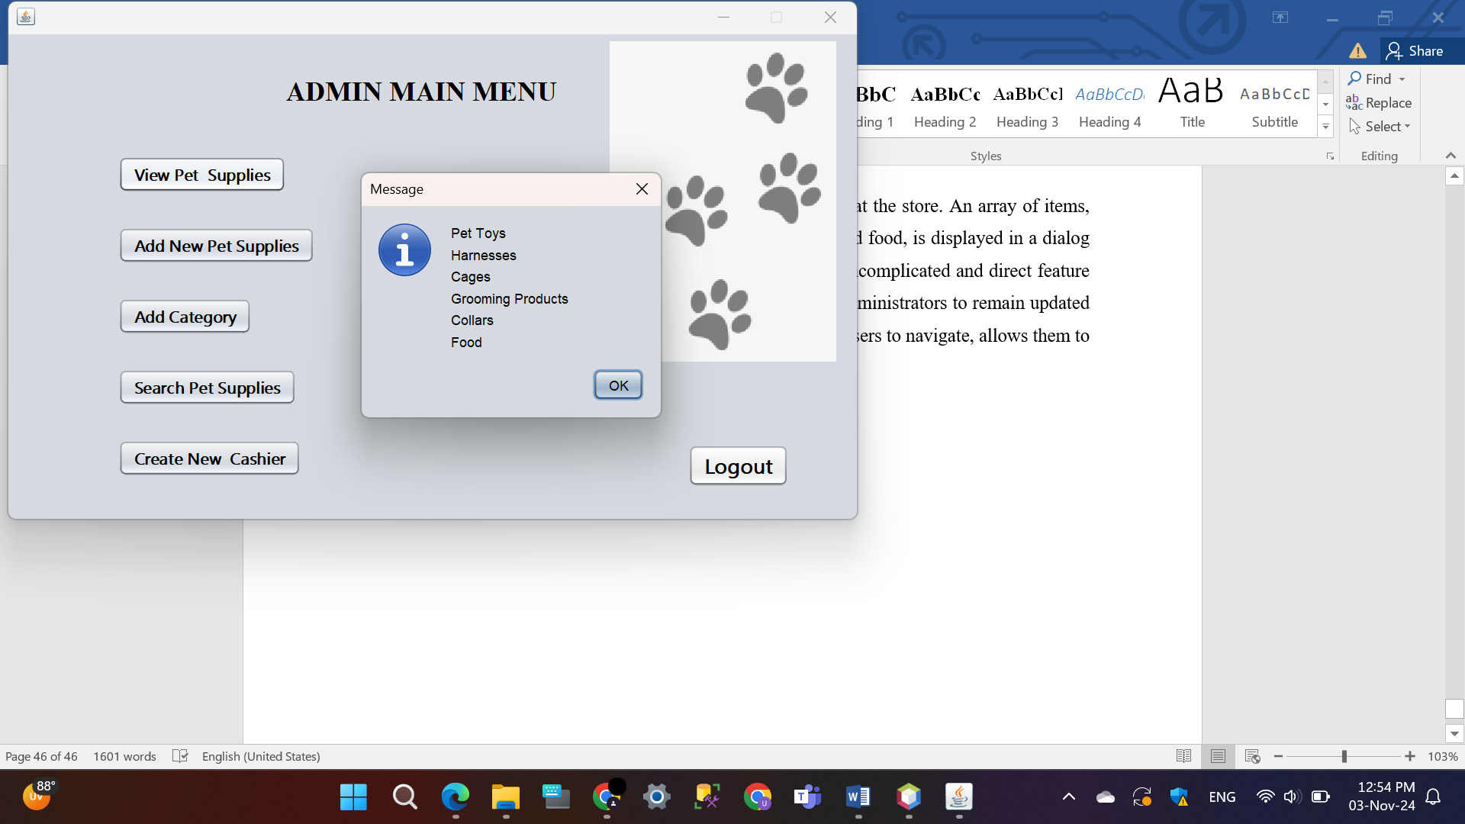**Manager**
* 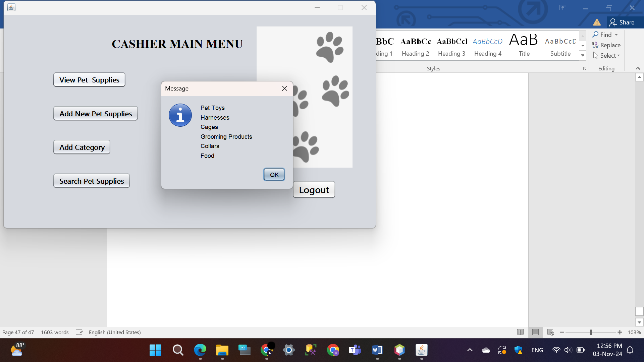**Cashier**

## Add New Pet Supplies Interface

The applications “New Supply Cashier” and “New Supply Admin” were created to effectively handle supply records in a retail store. When users or administrators open either app, they can input details like Supply ID, Supply Name, Supply Date, Category, Quantity, and Price into the text fields. Upon selecting the “ADD” button, this data gets stored in a file labeled “Supplies.txt” for later use. The button “View Added Supplies” enables users to view and showcase the file's contents, displaying all supplies that have been added. Furthermore, a “Back” button allows for easy navigation back to the previous screen. The user-friendly interface simplifies inventory control, making it easy for users to manage and monitor pet supplies.

* 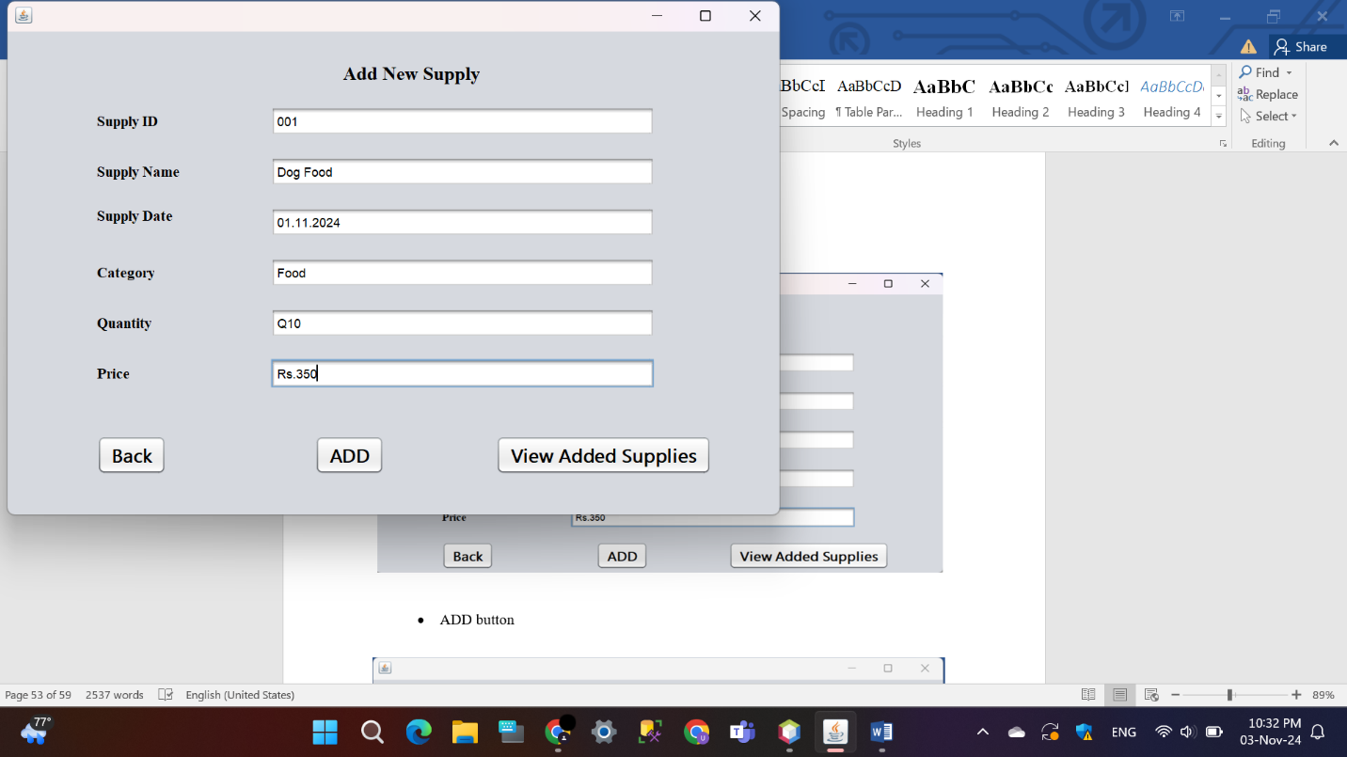**Manager / Cashier**

* ADD button

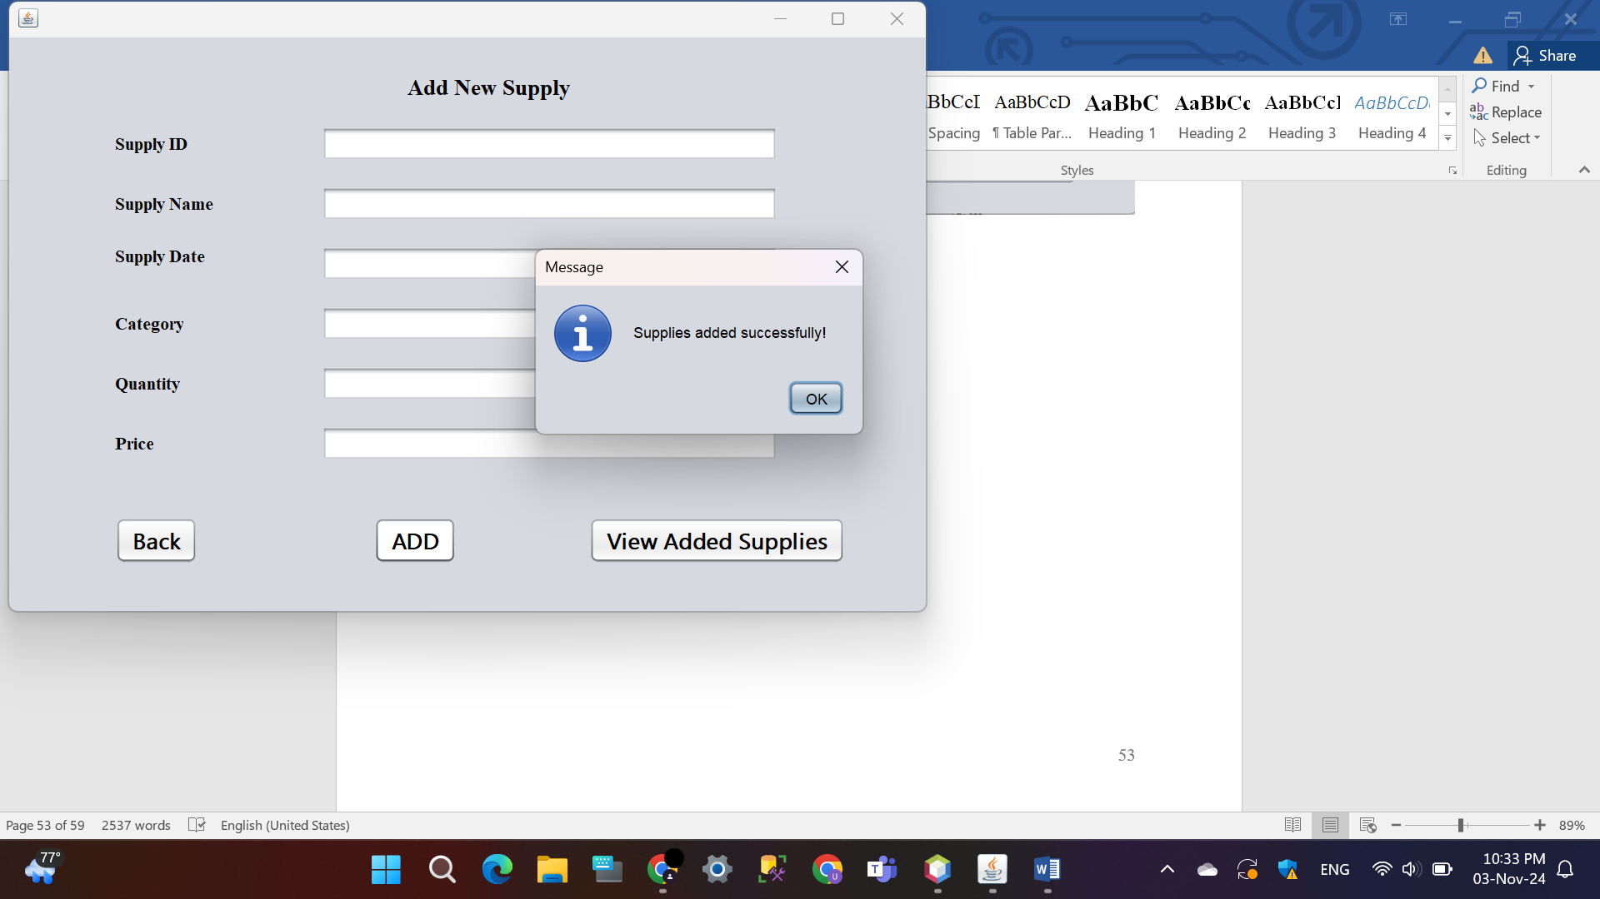

* View Added Supplies button

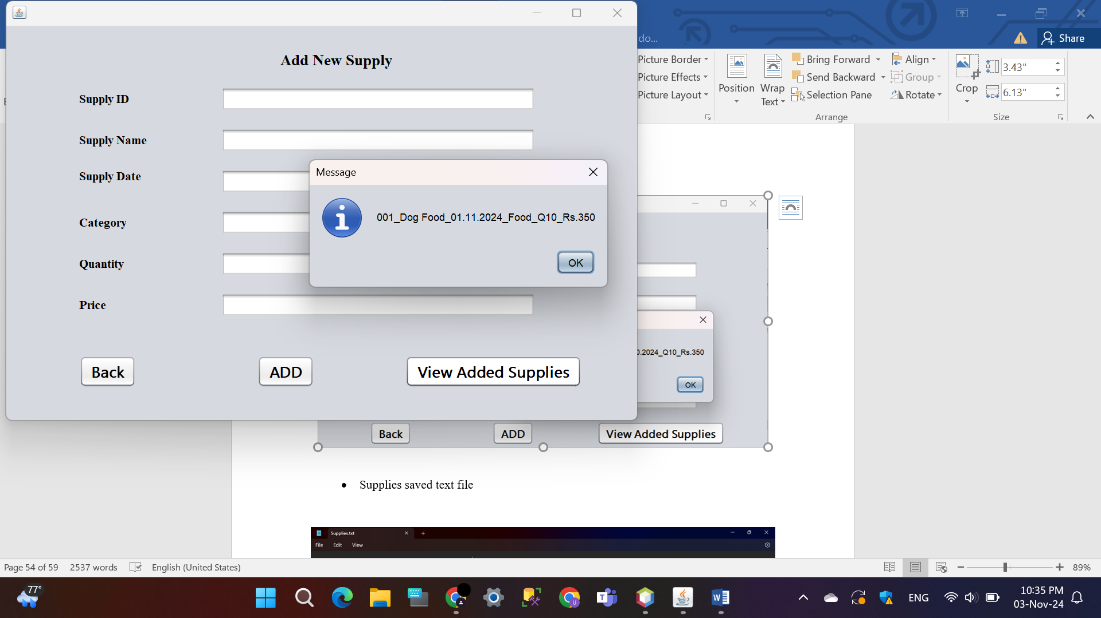

* Supplies saved text file

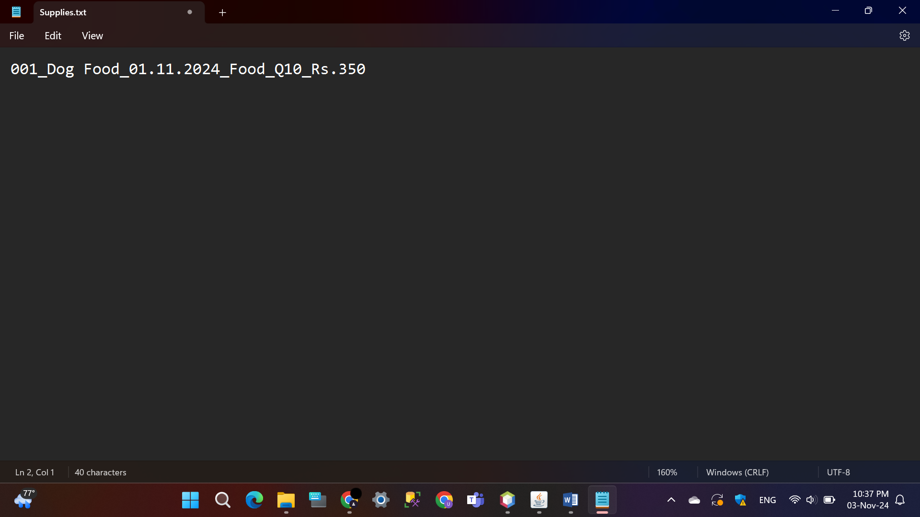

## Add Category Interface

The “AddCategory” and “AddCategoryCashier” apps help users efficiently handle inventory by adding new product categories with up to three related items. When users open either app, they are welcomed by an easy-to-use interface where they can enter the category name and item information. Once the data is inputted, users can click the “ADD” button to see a summary message of the inputted information, or use the “Back” button to go back to the previous screen. This efficient process makes it easy to manage inventory quickly and effectively while maintaining the three-item limit per category.

* **Manager / Cashier**

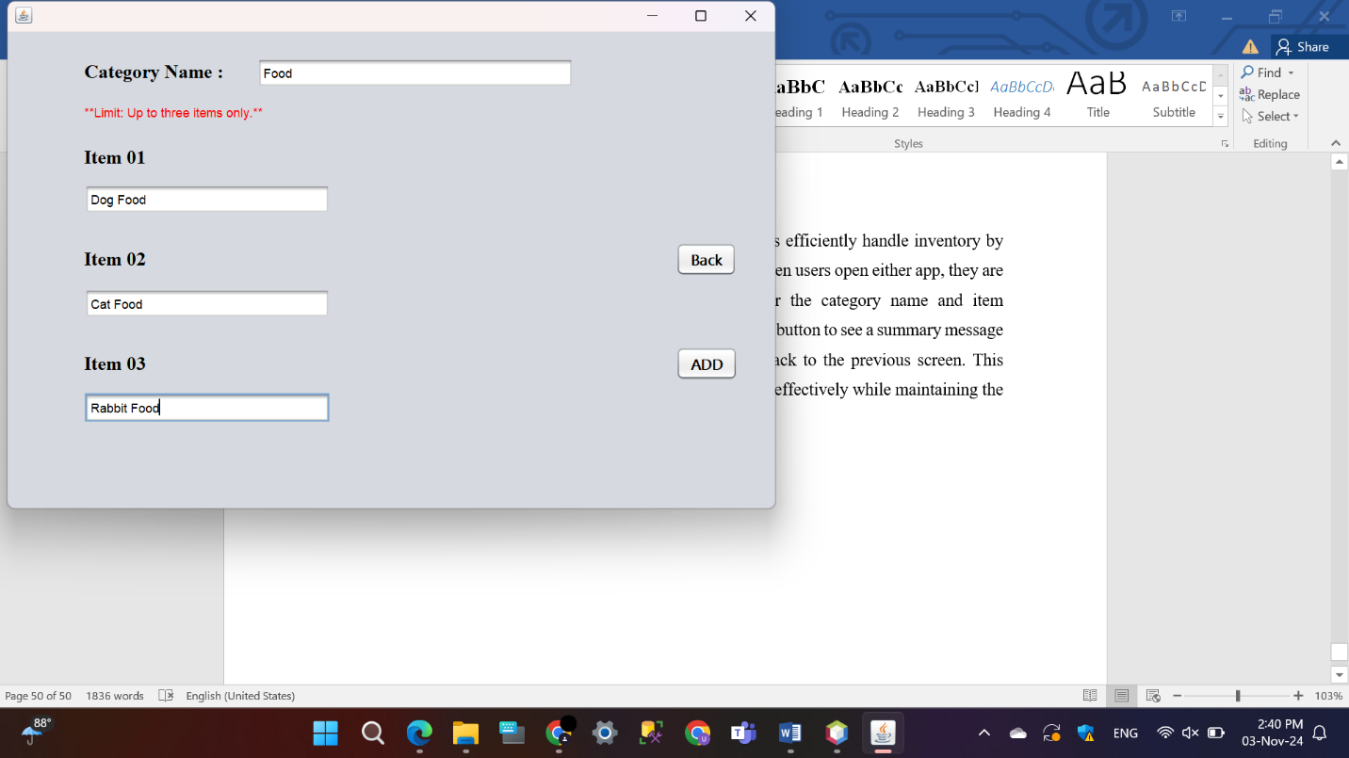

* 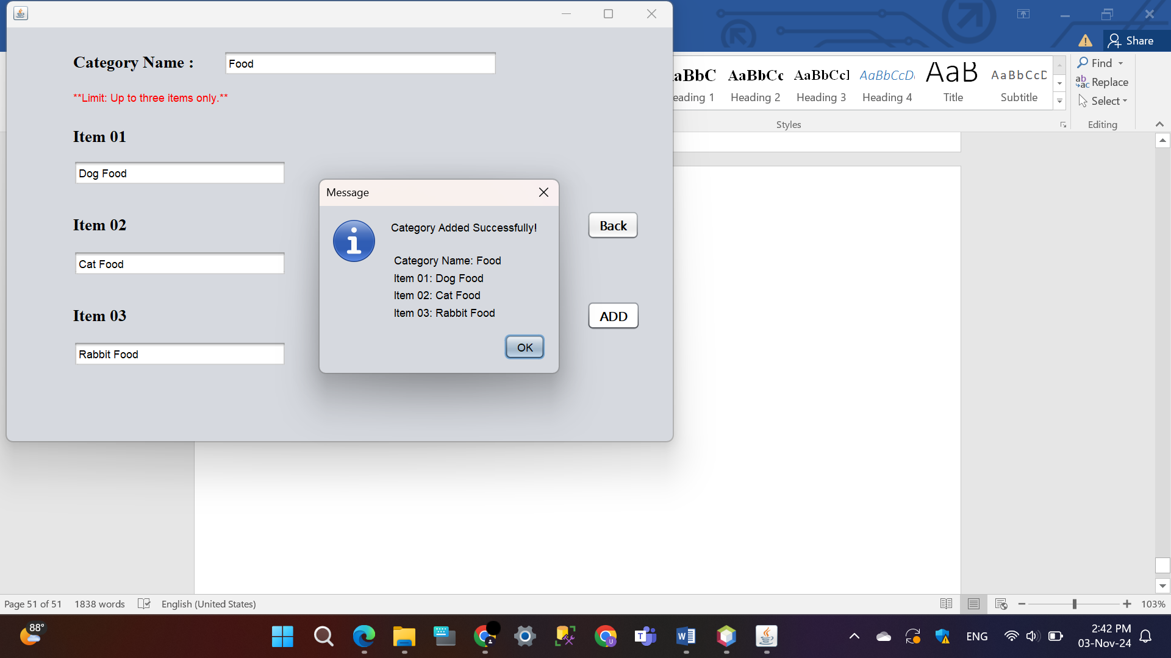ADD button

## Search Pet Supplies

The “SearchPetSupplies” and “SearchPetSuppliesCashier” apps enable users and cashiers to easily find pet supplies by typing the item name in the search bar and pressing “Search”. If the item is located, a message will confirm its availability; if not, the user will receive an alert indicating it is not available. The “Back” button enables users to go back to the screen they were on before. Both apps have a straightforward, user-friendly layout that simplifies the process of searching inventory, making it easy and convenient for both regular users and cashiers.

* **Manager / Cashier**

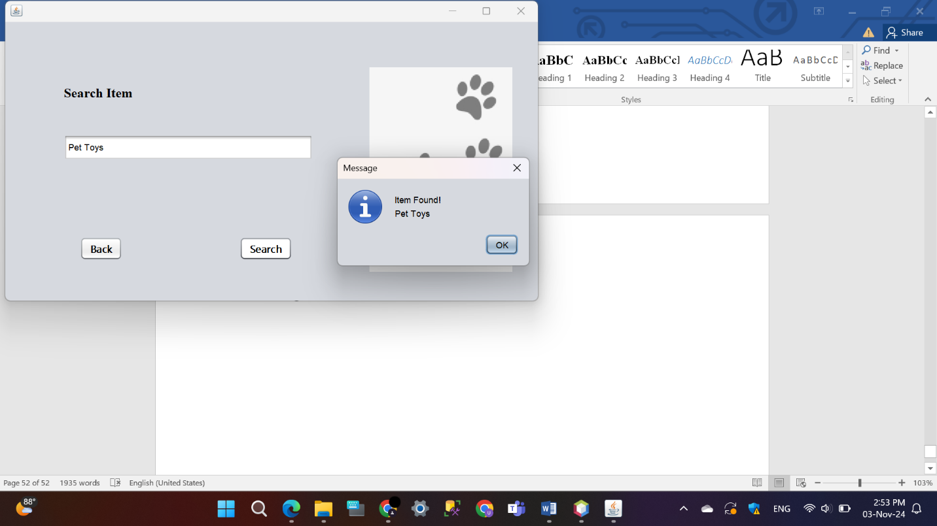Available Item

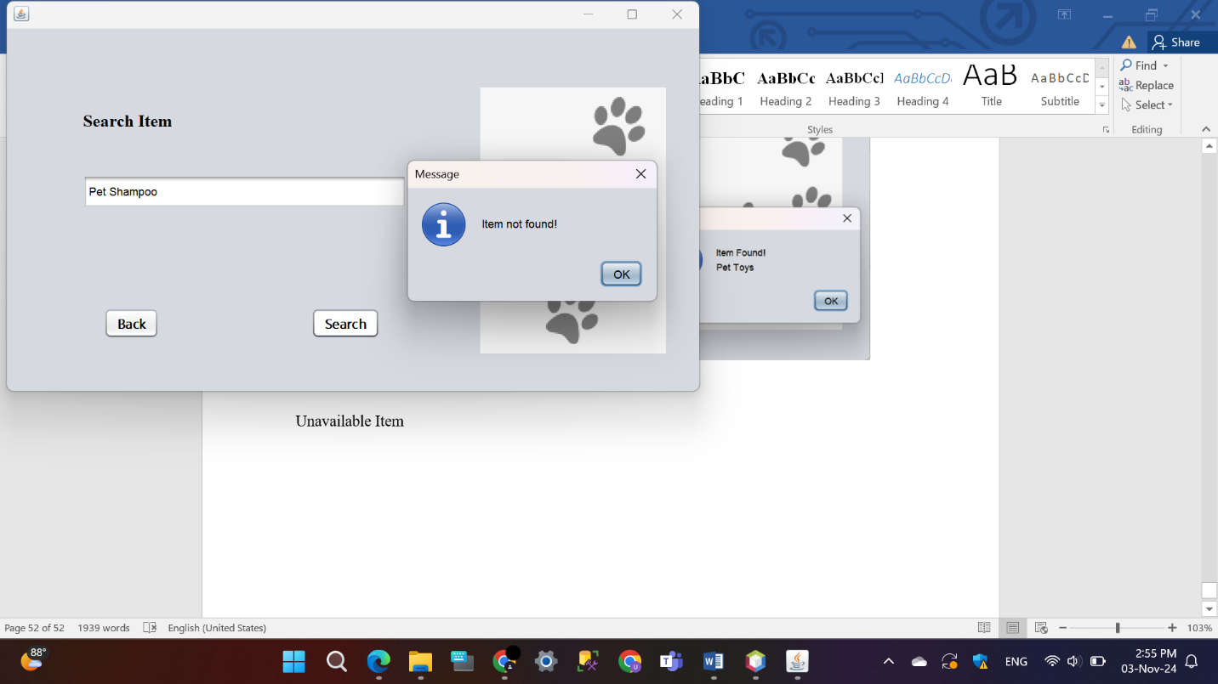Unavailable Item

## Create New Cashier

The “NewUser” app is created to make it easier to add new cashier profiles. Fill in the necessary information for every field in the application: Cashier ID, Name, Phone Number, Address, and Email. After entering all necessary information, click the “Add User” button to finalize and store the new cashier profile. A confirmation message will be shown, displaying the entered information. To go back to the previous screen, simply press the “Back” button. The interface, which is easy for users to navigate, allows for swift and simple inclusion of cashier profiles into the system.

* **Manager**
* 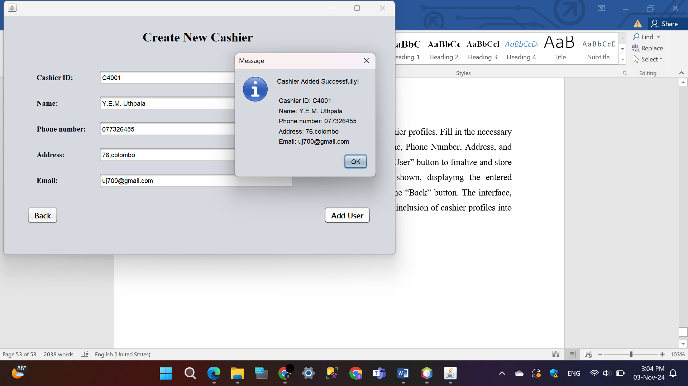Add User button